## Web Chat bot for Public School Registrations in Canada

Step 1: Create an Azure Machine Learning Workspace by signing into Azure portal with Azure Subscription.

* Create or select a Resource Group with Unique name: MachineLearning
* Select nearest geographical Region: East US
* The remaining selection will automatically take the default values as per the workspace name and which will be created for our workspace.

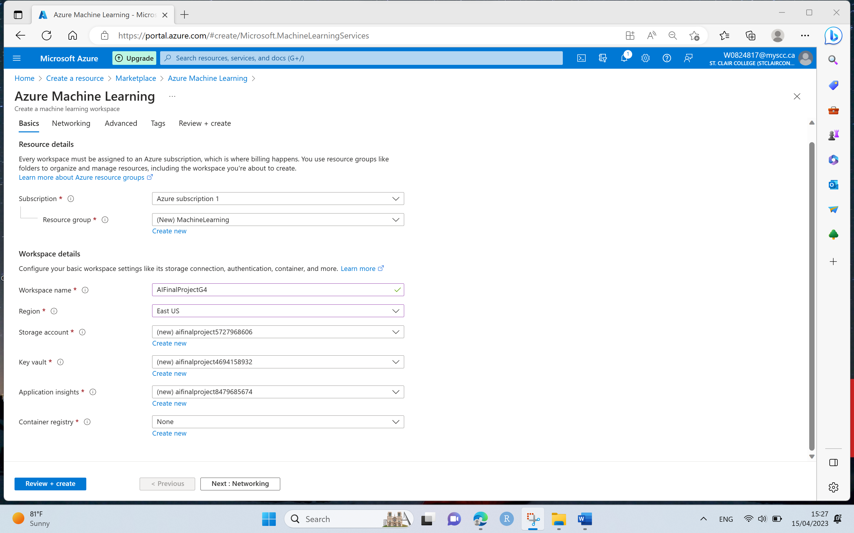

* Select Review + Create and then click on Create to create a workspace after validation passed.

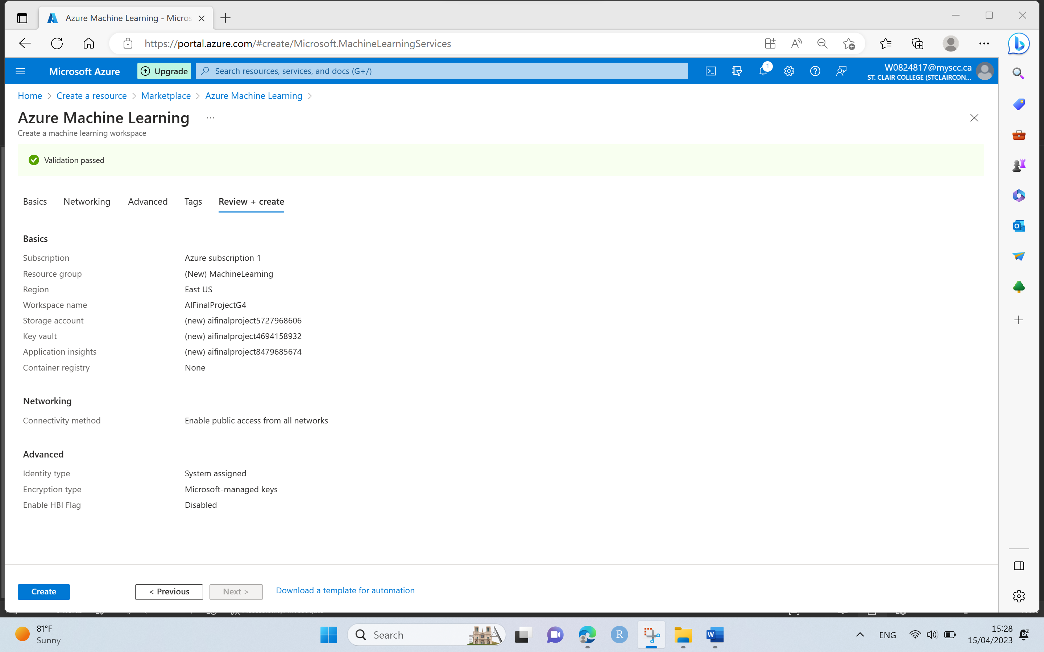

* Workspace creation will take a few minutes and click on Go to Resource once the deployment is completed.

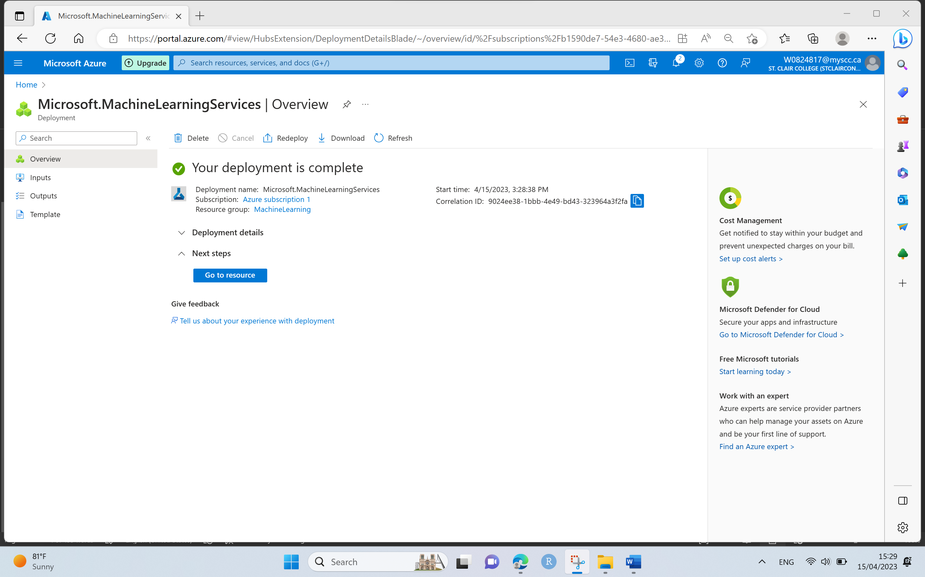

Step 2: Create Compute Instance by selecting Virtual Machine and type of Virtual Machine as CPU.

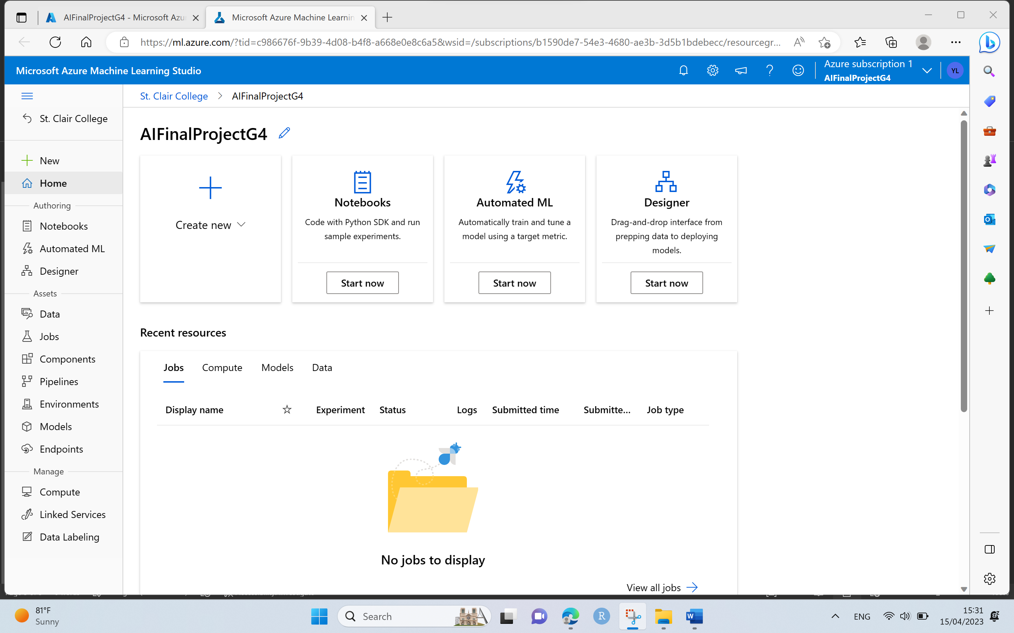

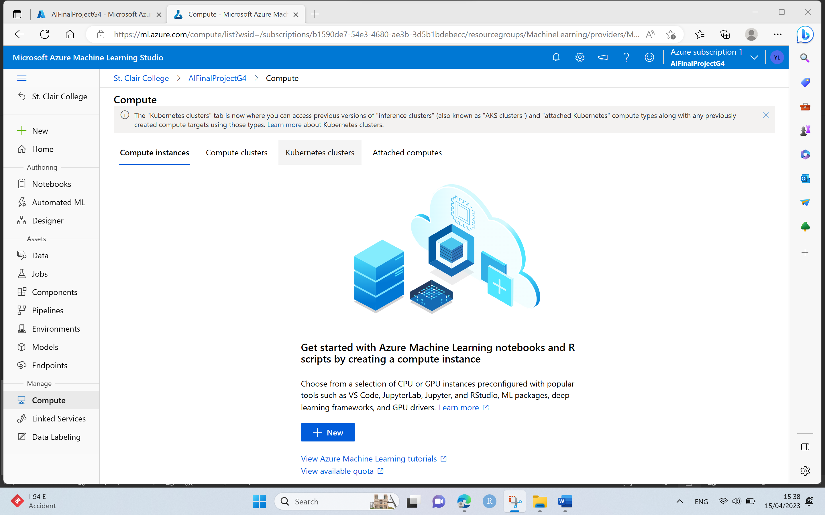

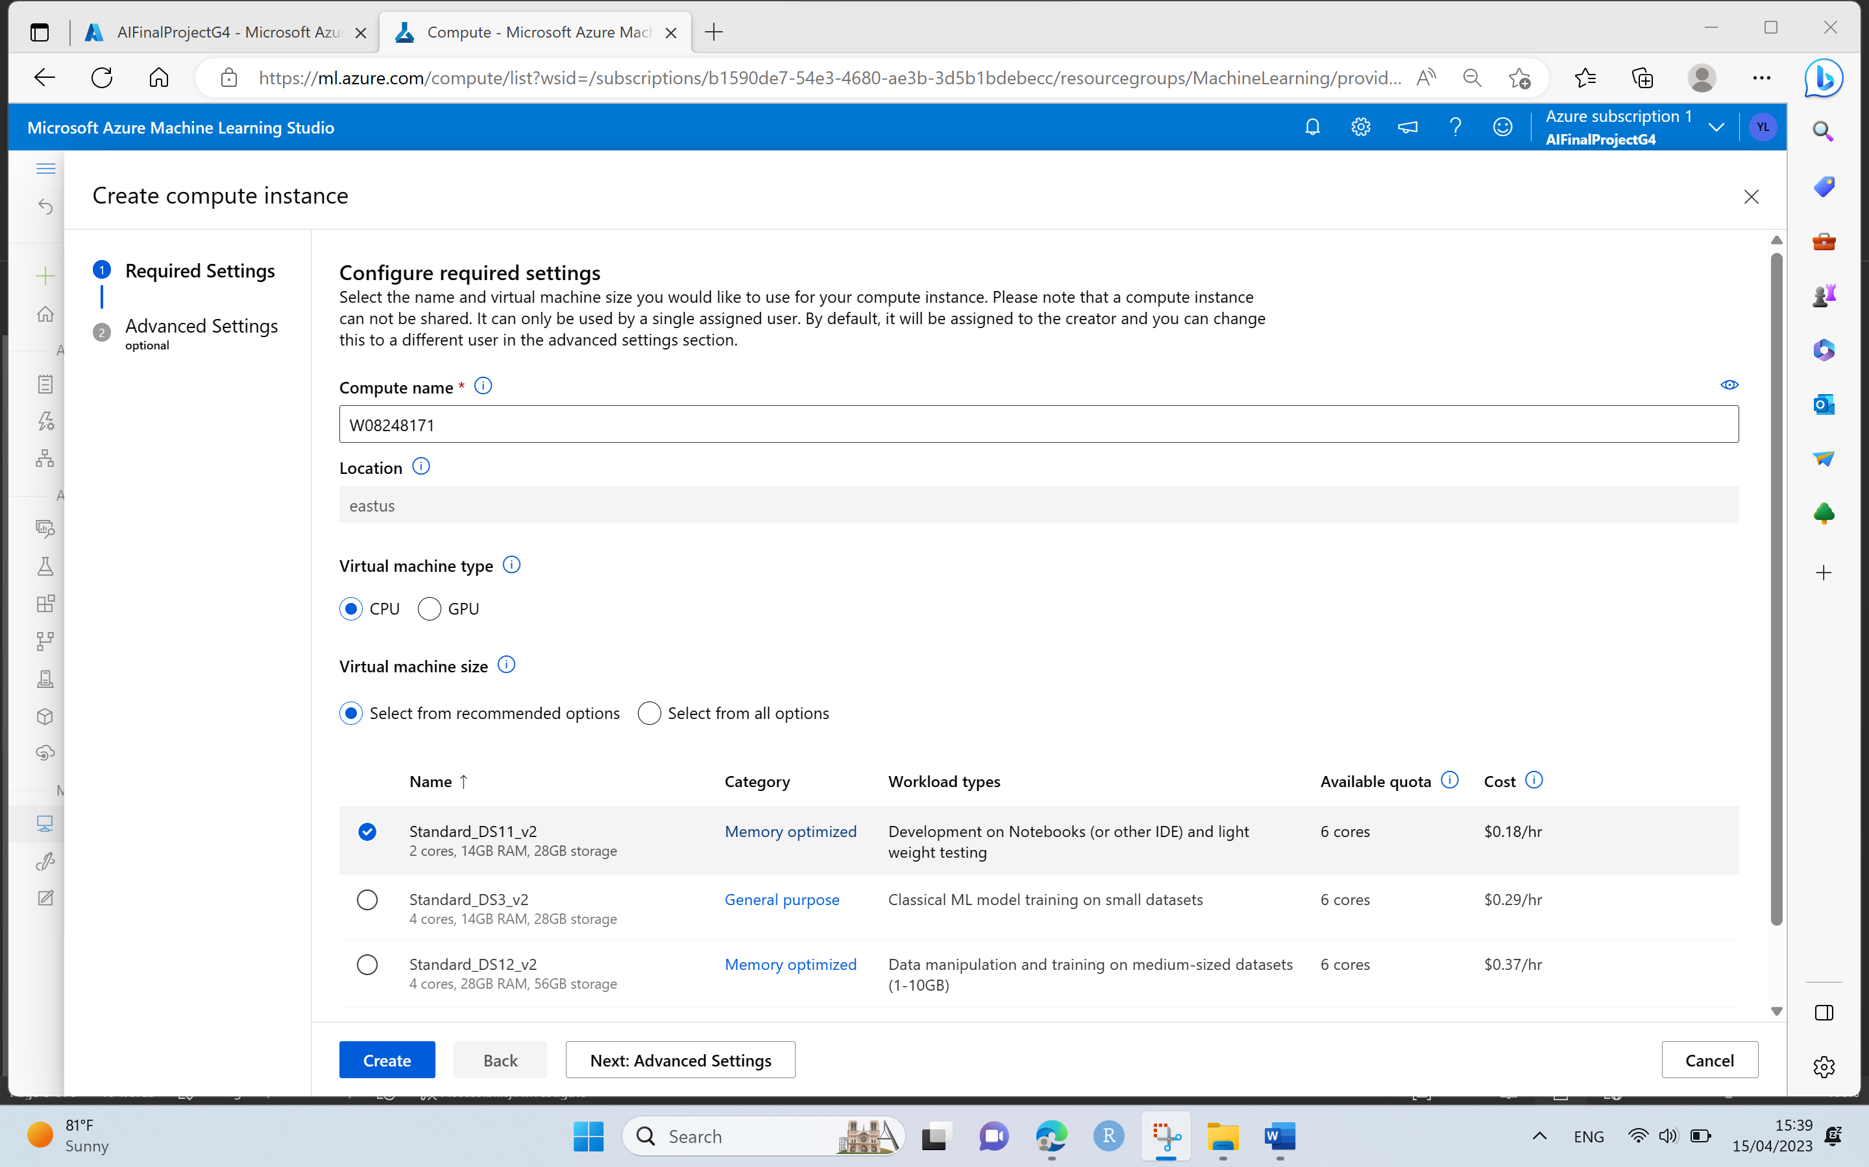

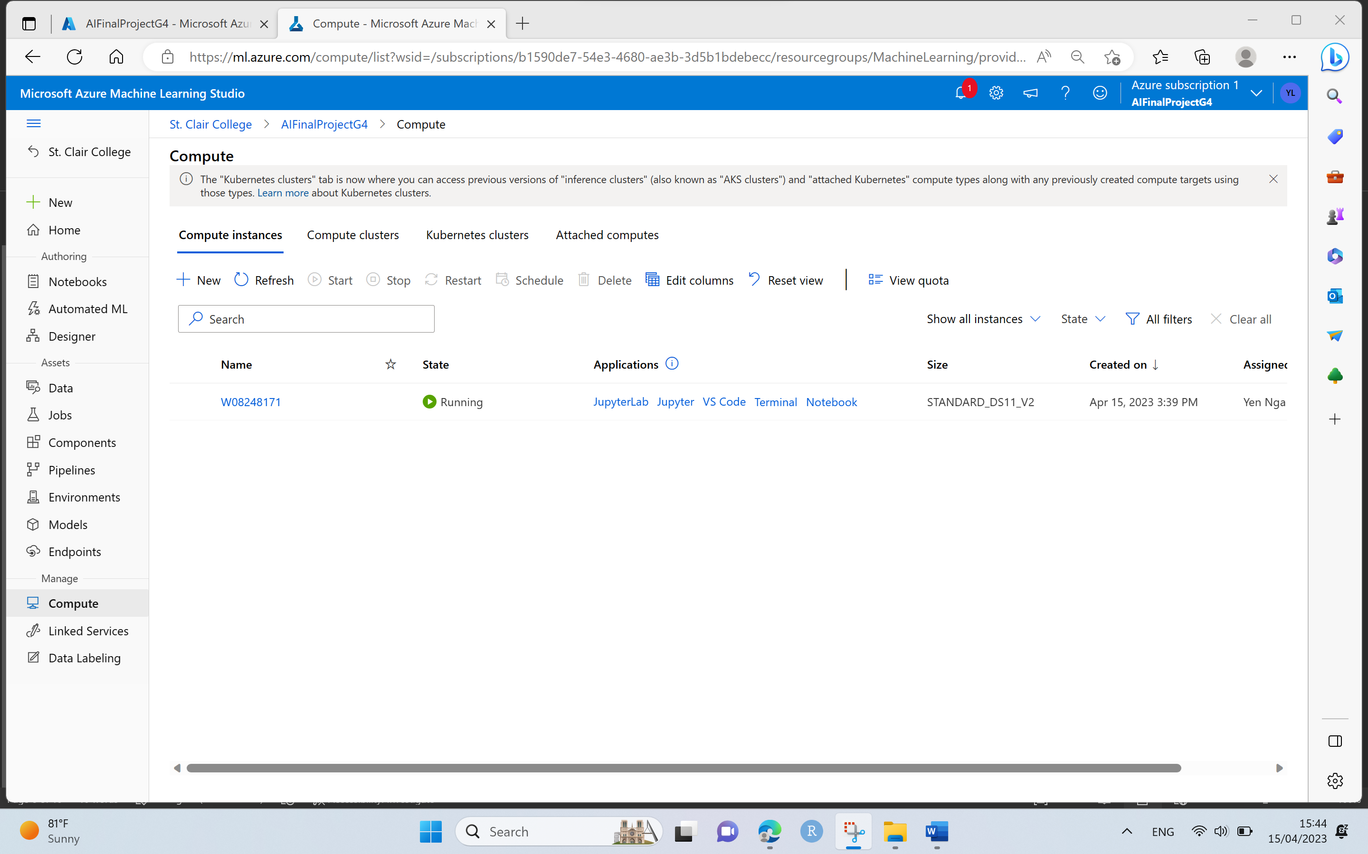

Step 3. Launch the Azure Machine Learning Studio and go to Notebooks and add File by creating a new file.

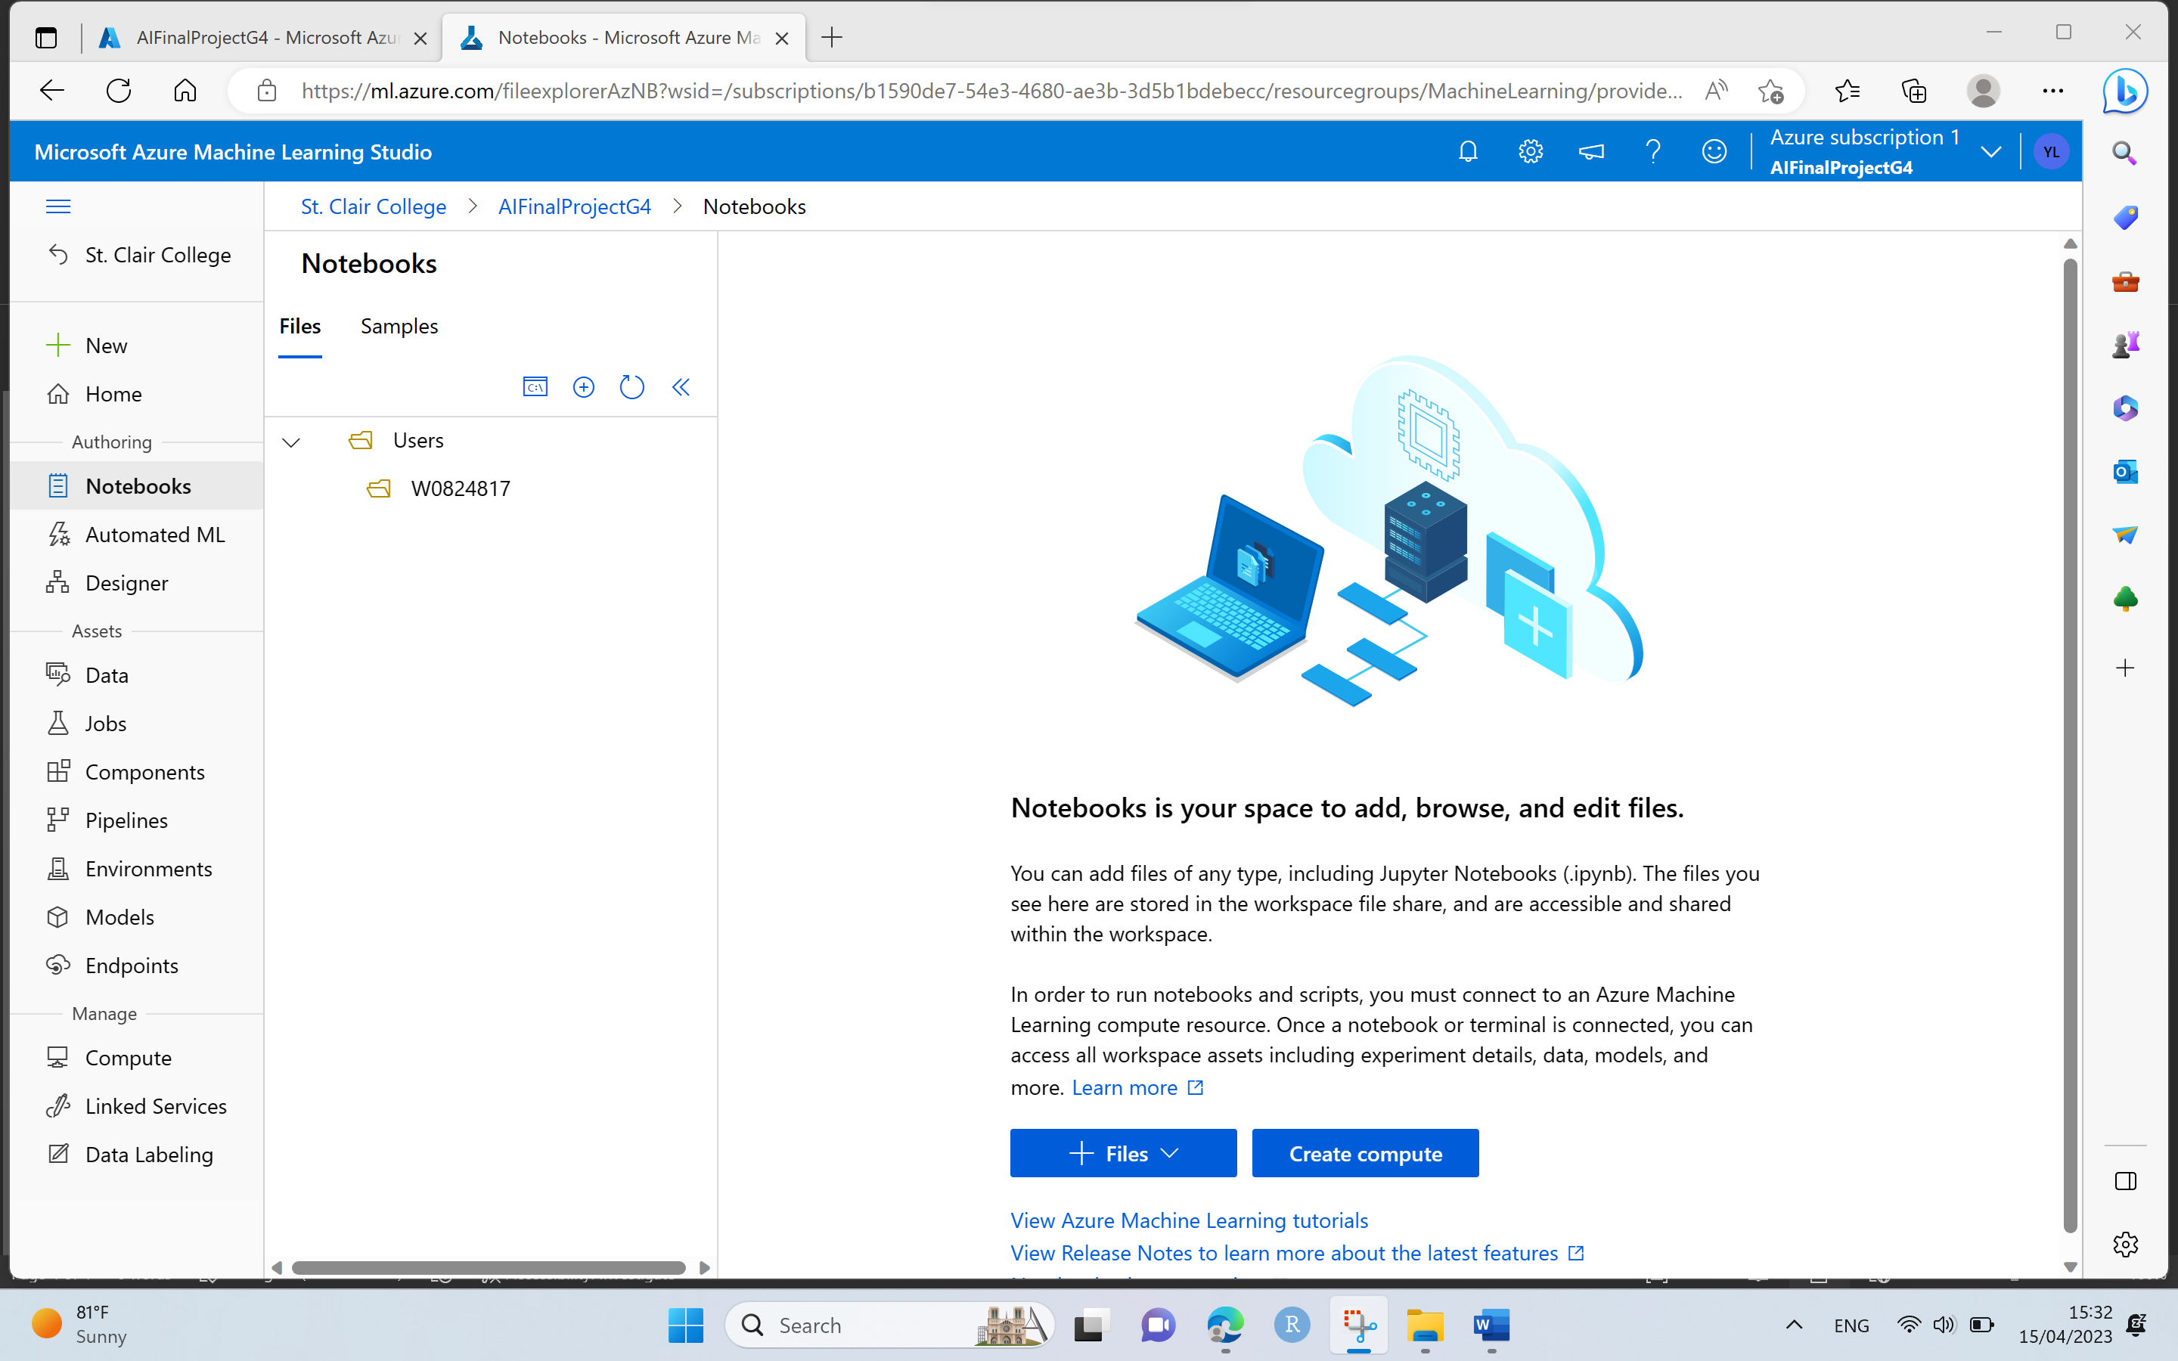

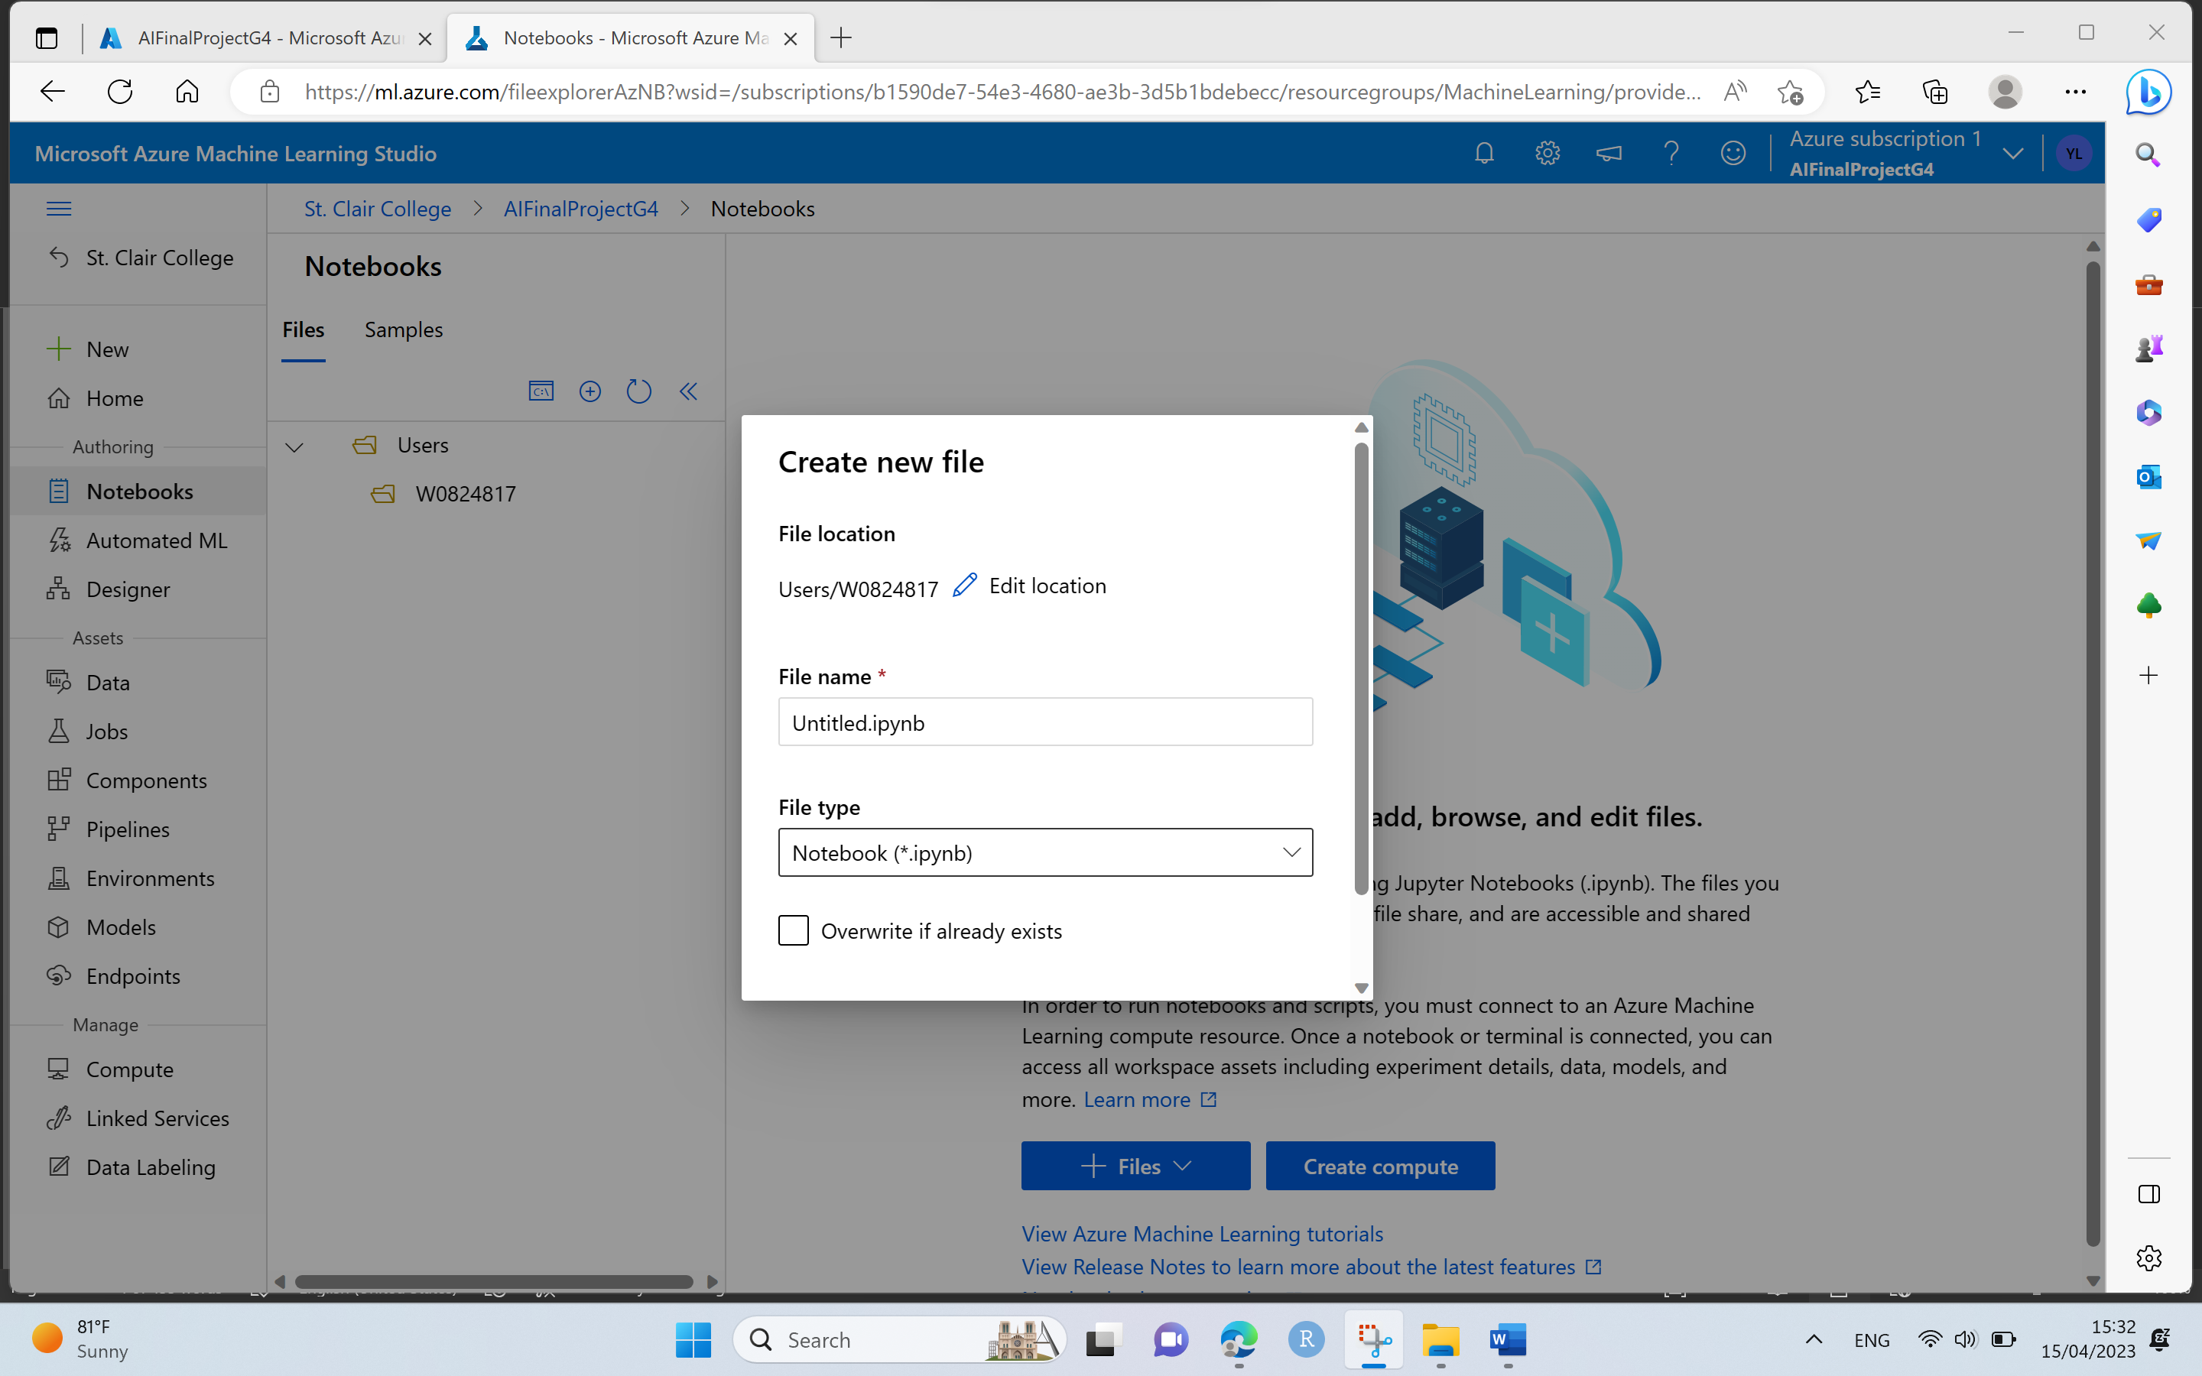

* Create new python notebook file and add and run the GitHub URL to get the different python notebooks from Azure machine learning fundamentals.

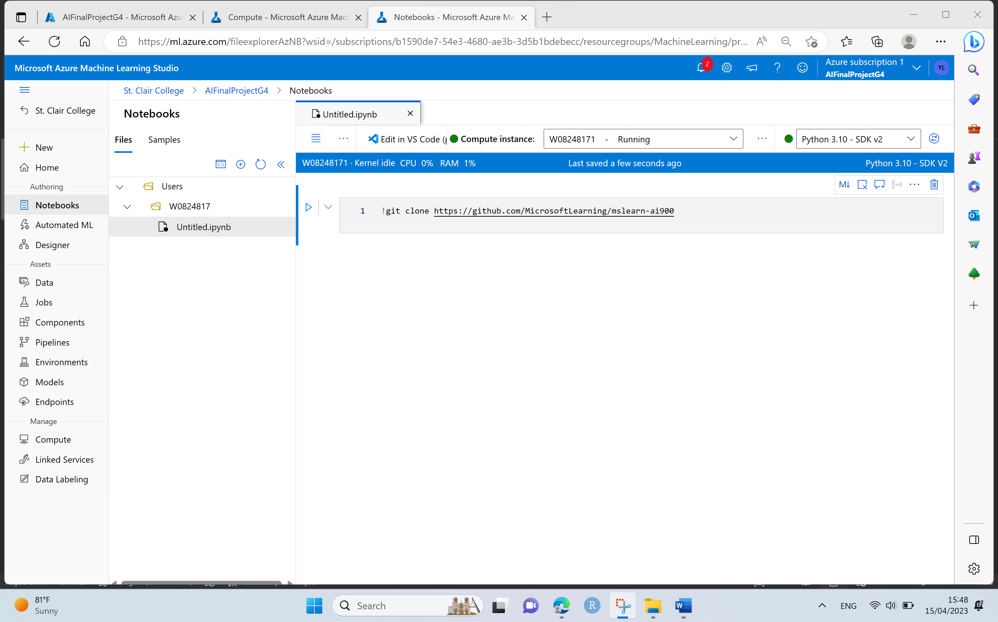

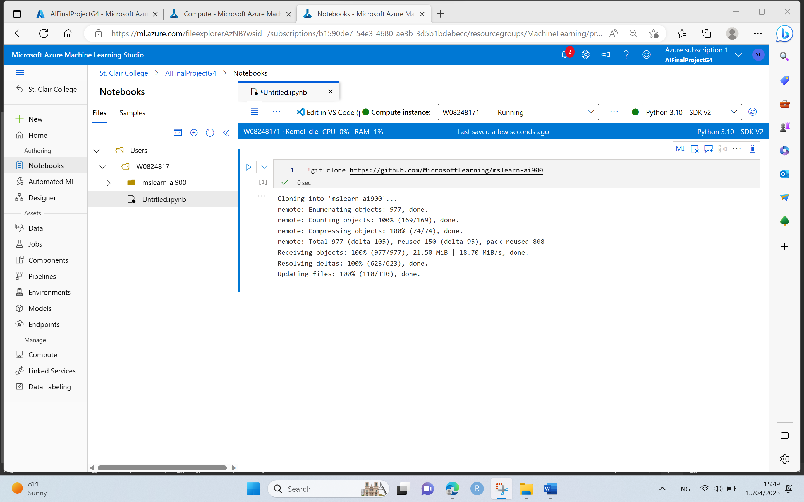

* Select the QnA Bot notebook for Conversional AI fundamental to create a chat bot.

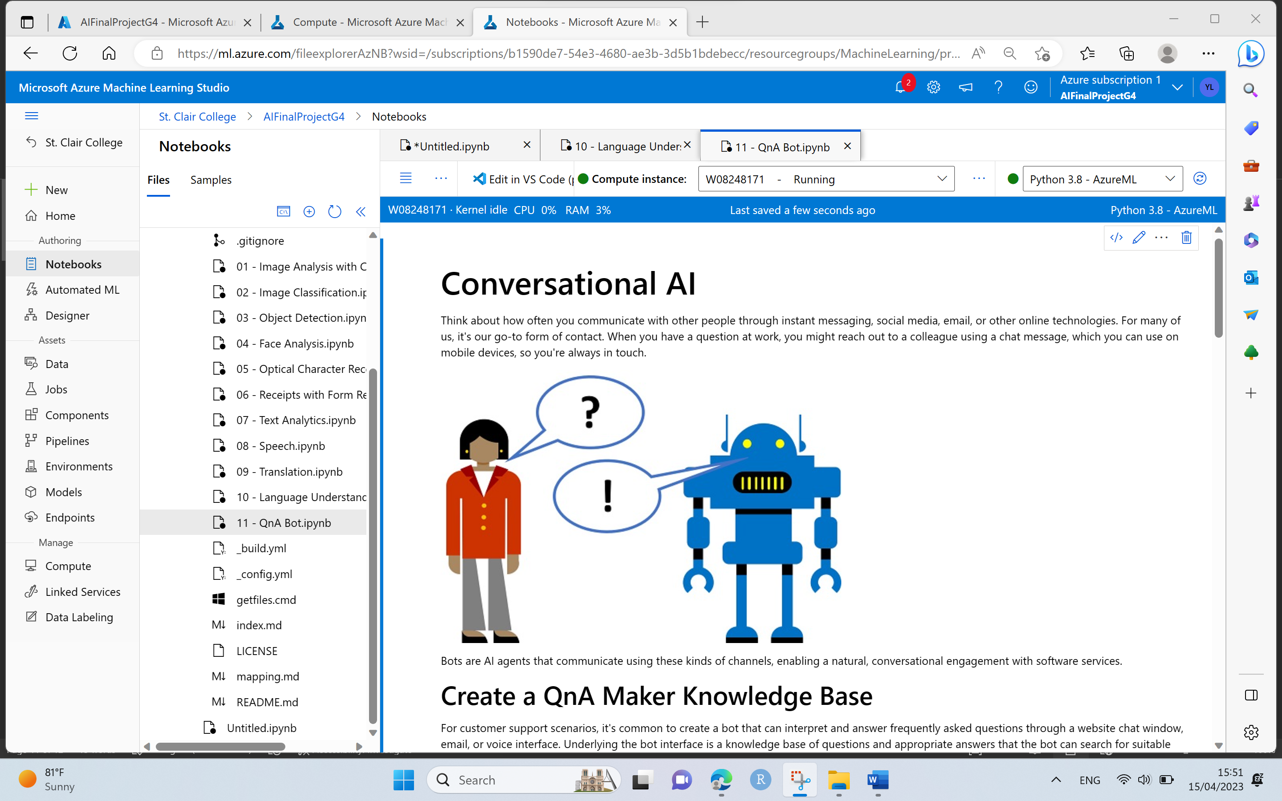

Step 4. Go to Azure Machine Learning Home and Search for Language Service and click on Create to Language Service Resource.

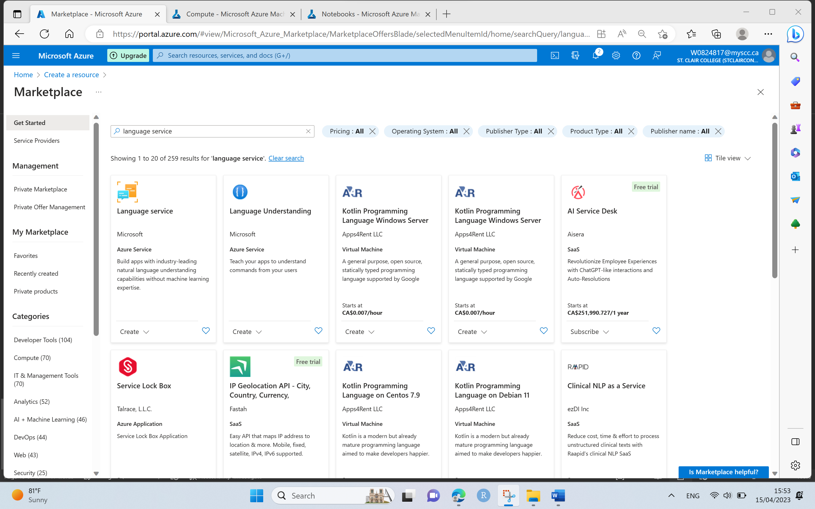

* From Language Studio, Select the Custom Question and Answering feature to answer user’s questions over given collection of data and continue to create a Language Service Resource.

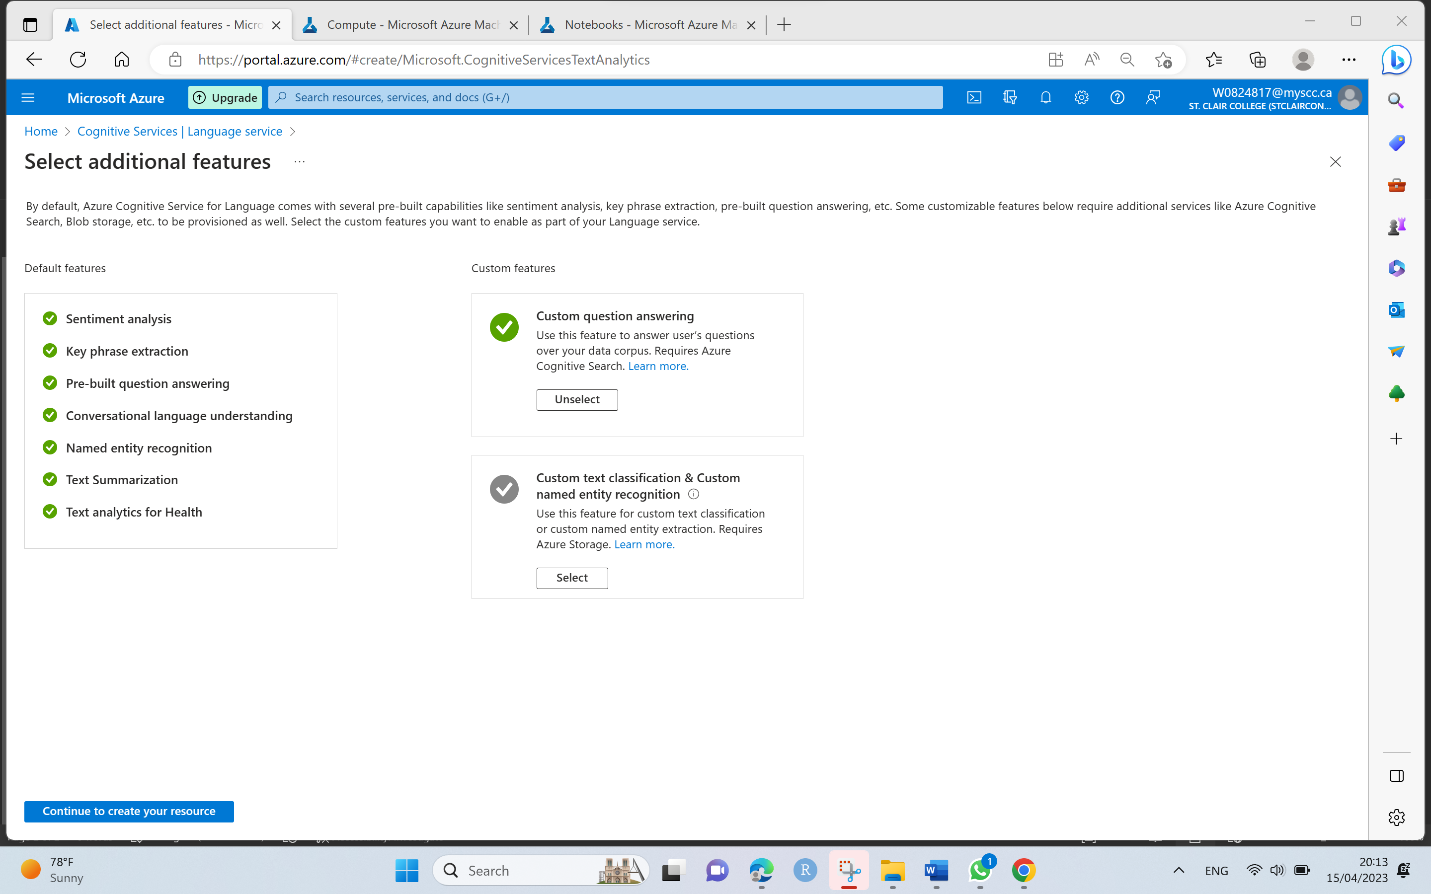

* On the Create Language page, input the following Azure Subscription details, resource group which already created earlier in step 1, Instance details with geographical closest region, unique name for Language instance and pricing tier as below.
* Click on Review + Create by giving consent to Responsible AI notice.

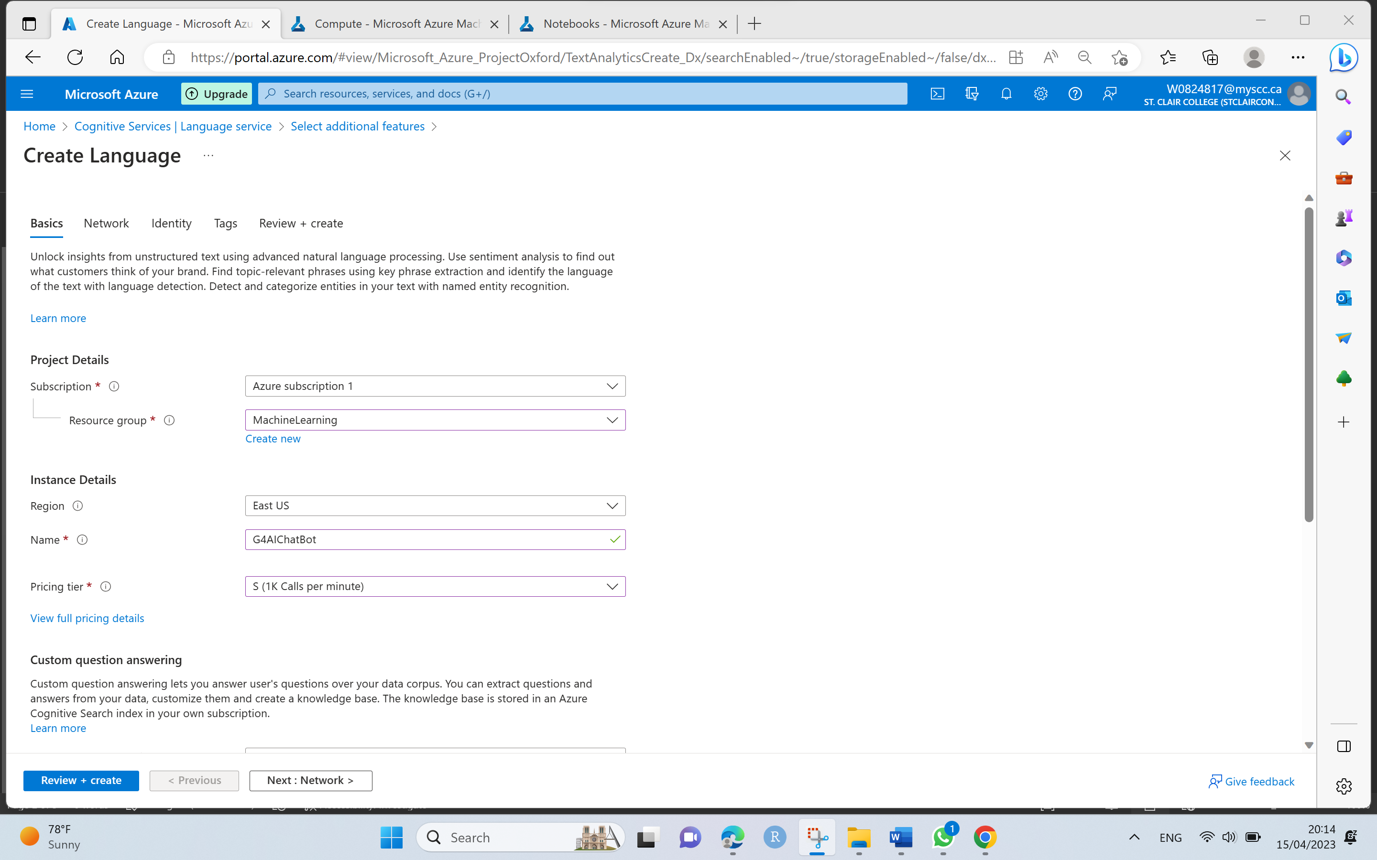

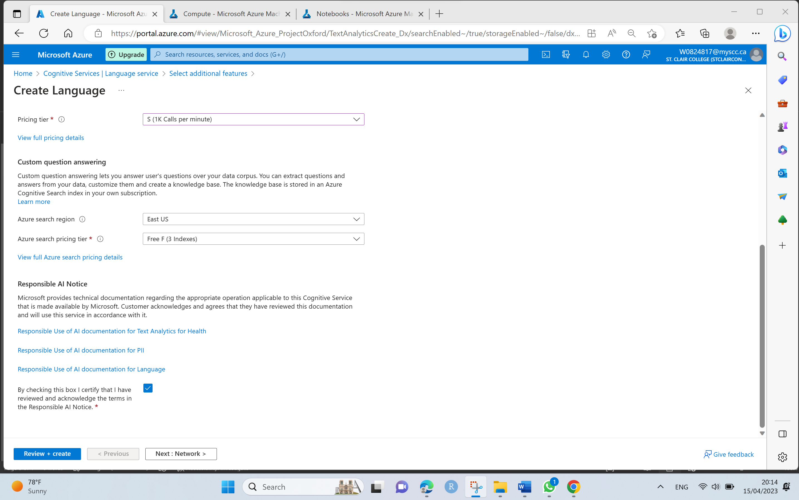

* Click on **Create** once Validation Passed to create a Language Service which will support our custom question and answering knowledge base for Chat Bot.

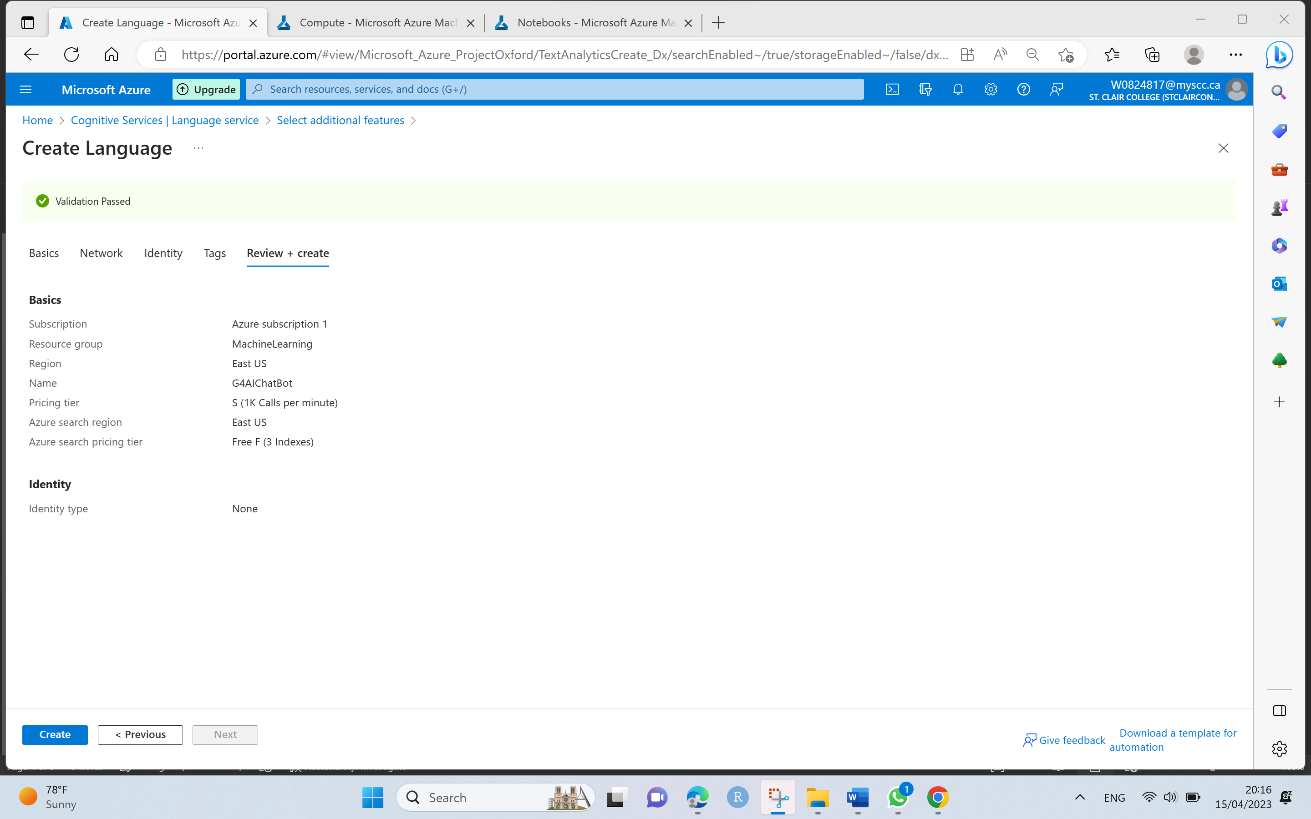

* Once the deployment is complete, Go to Resource Group.

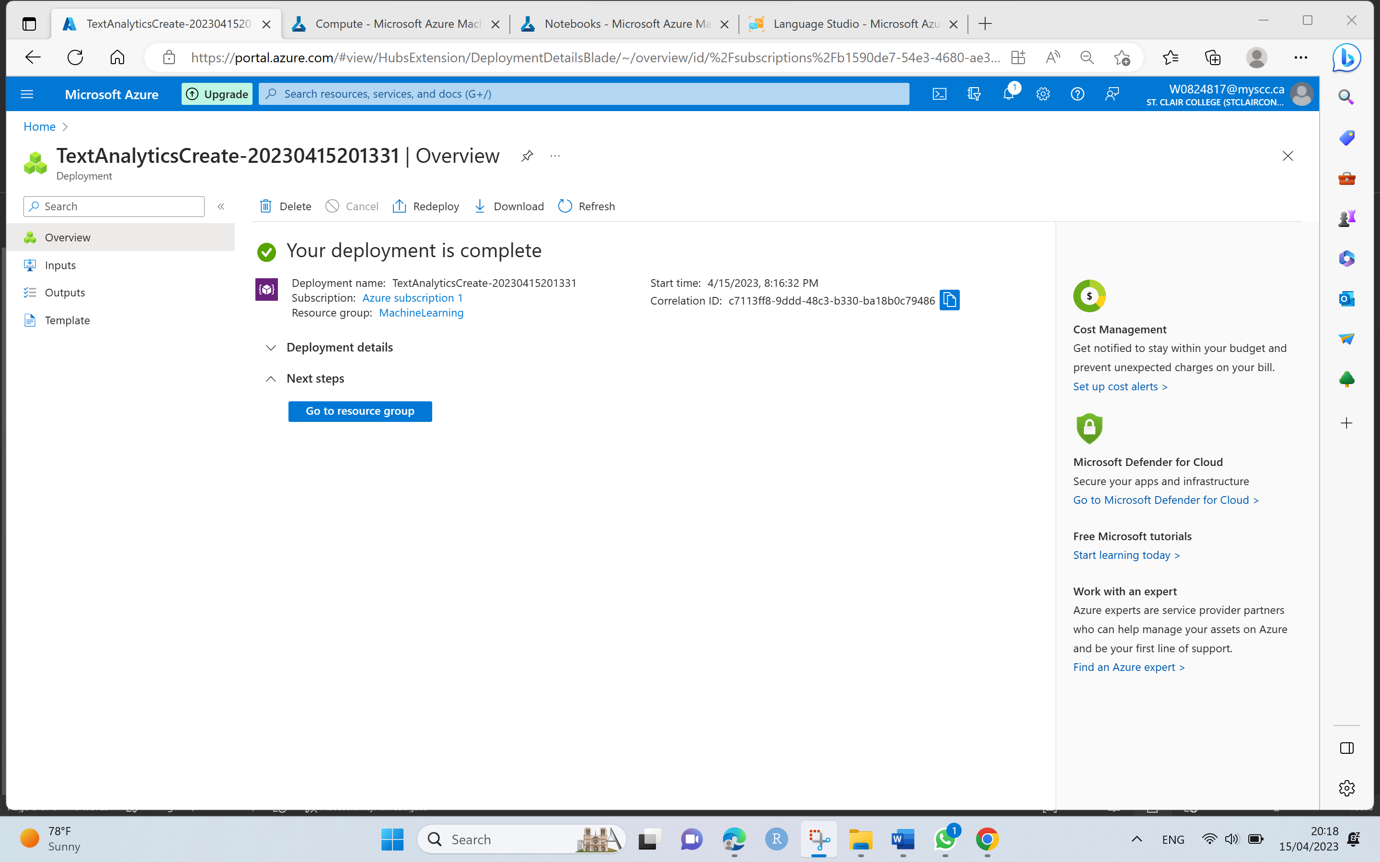

Step 5. Open the Language Studio portal at <https://language.azure.com> in a new browser tab by signing Microsoft account with associated Azure subscription.

* Select the following settings to choose language resource such as: Azure directory, Azure Subscription and Language Resource type and Name which is already created previously in Step 4 as below which is used for Custom Question and answering knowledge base project.

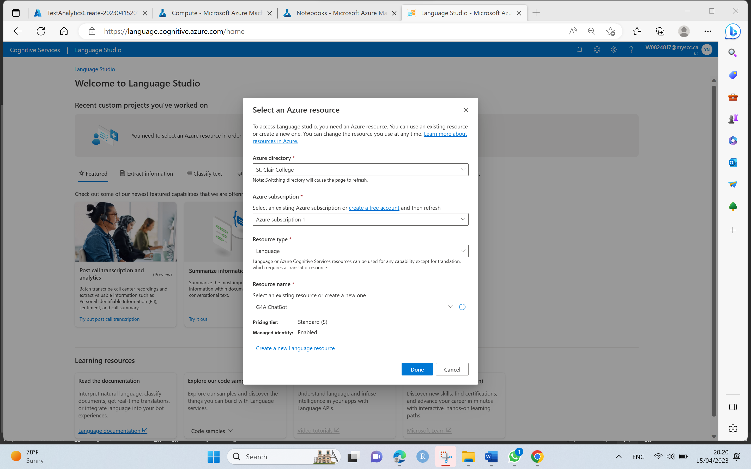

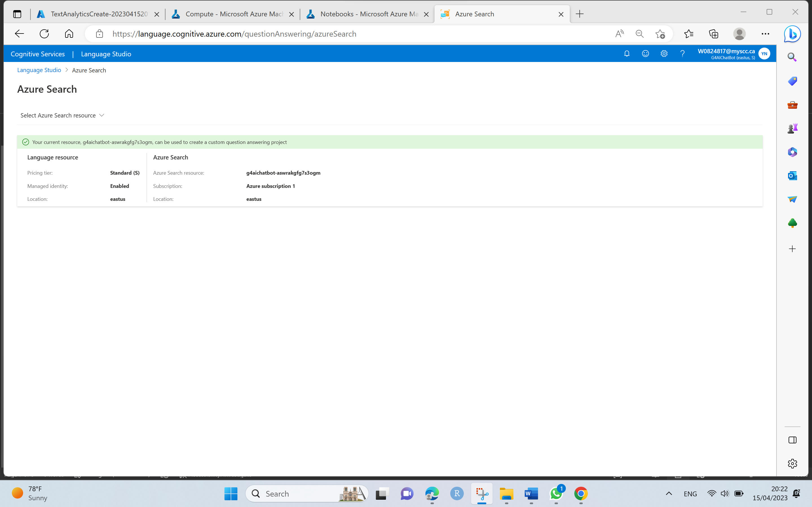

Step 6. Click on the Create new project and select custom question answering from the top of Language Studio portal.

* Choose below selection for creating new project for our resource as I **want to select the language when I create a project in this resource.**

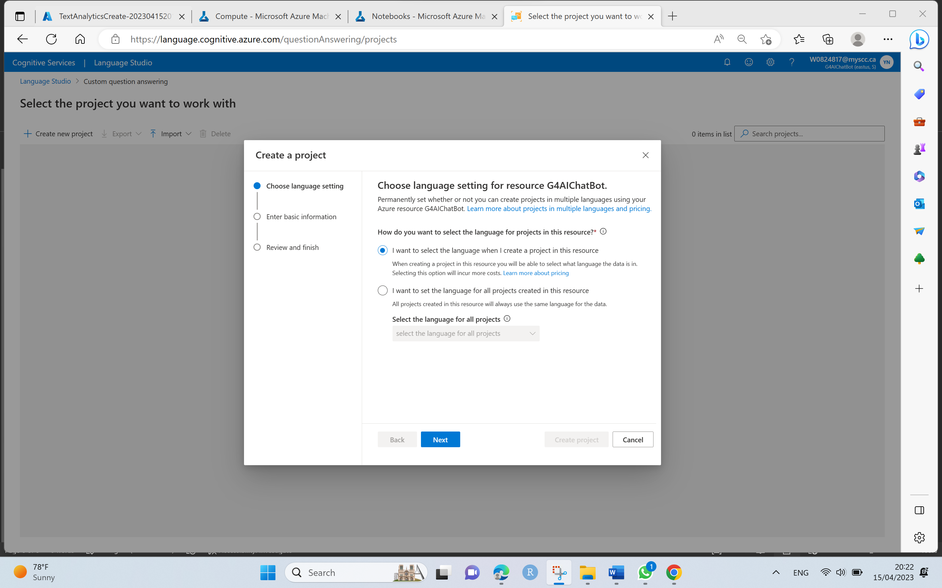

* Enter the basic information for the knowledge base project with Unique Name, Description, Source language and Default answer when no answer is identified from the knowledge base is returned.

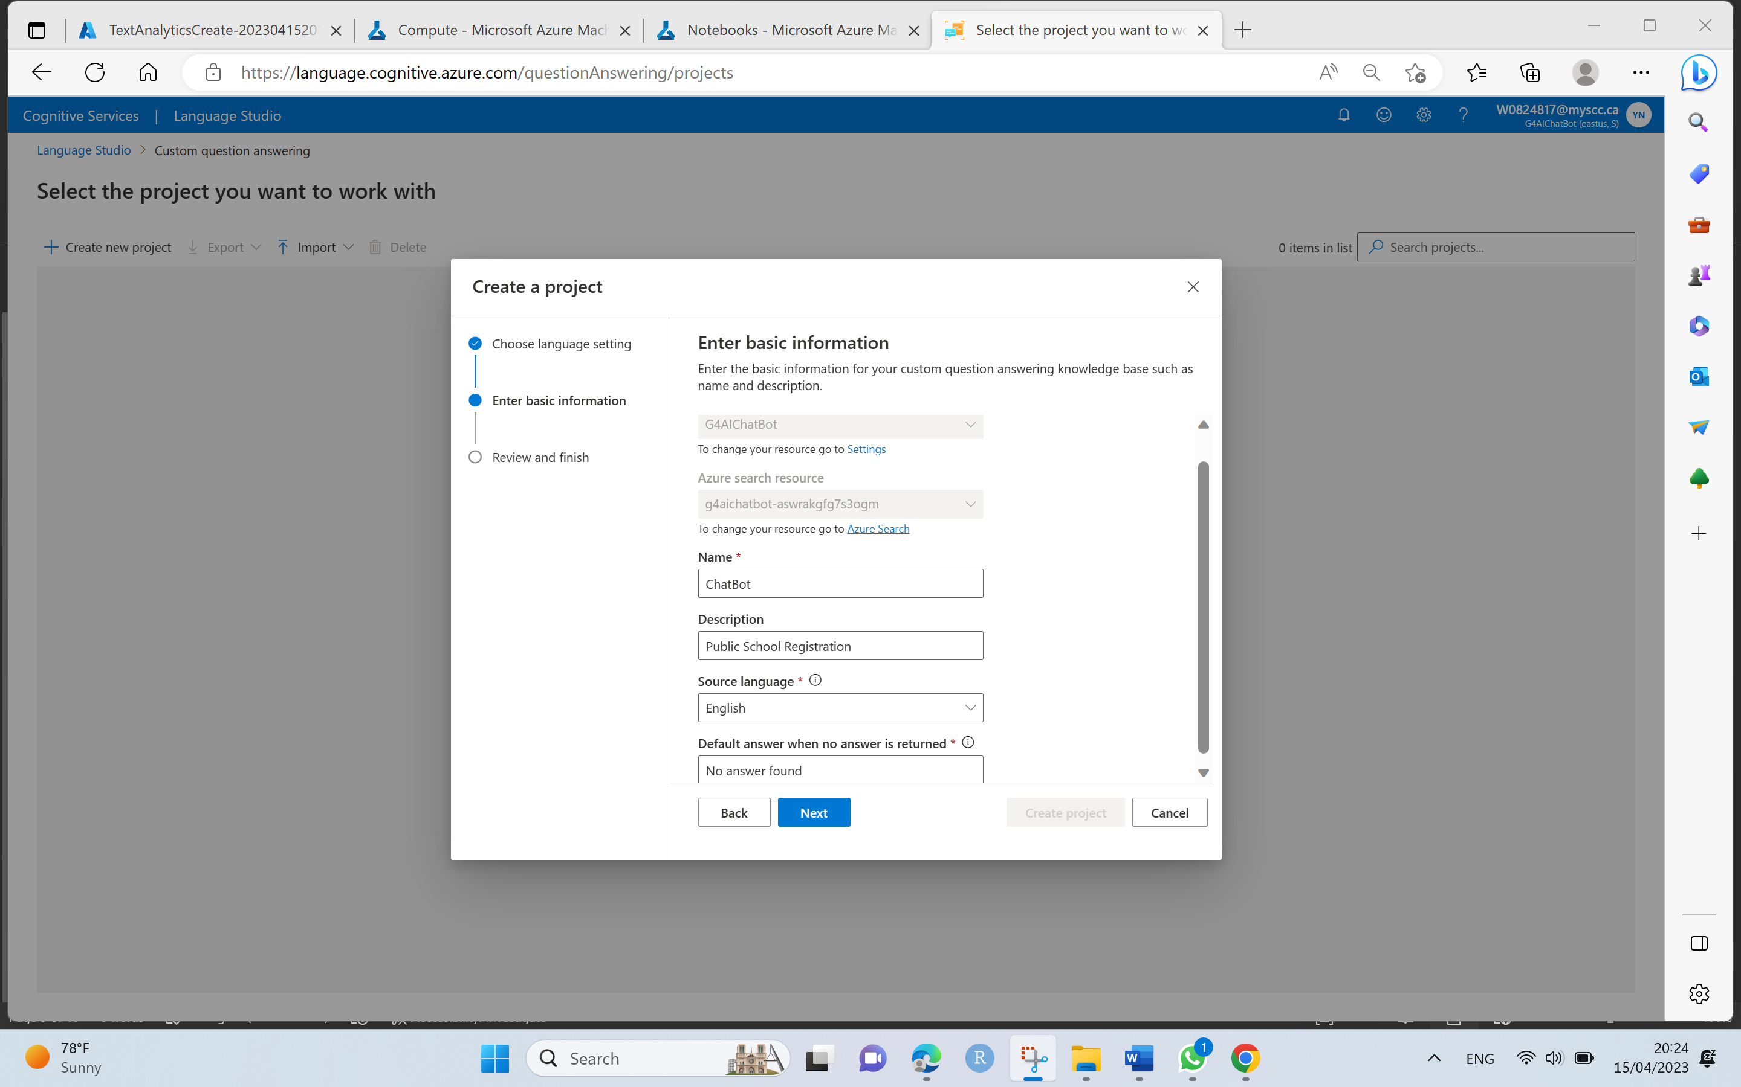

* Review the selection of inputs and click on Create Project.

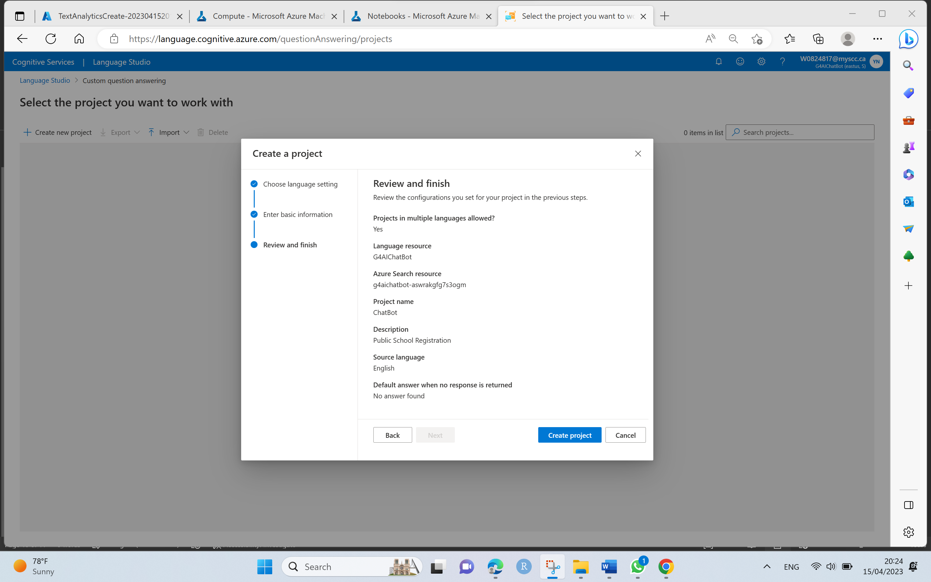

Step 7. Once a project is created, we can automatically direct to Manage Sources page, click on + Add source and select the URLs to give Knowledge base inputs via following GitHub URL.

* Click on add url and give the URL name and URL address as below with classify file structure as Auto-detect option.
* URL: <https://github.com/srilakshmigummadidala/PublicSchool_ChatbotG4/raw/main/registration_faq.docx>

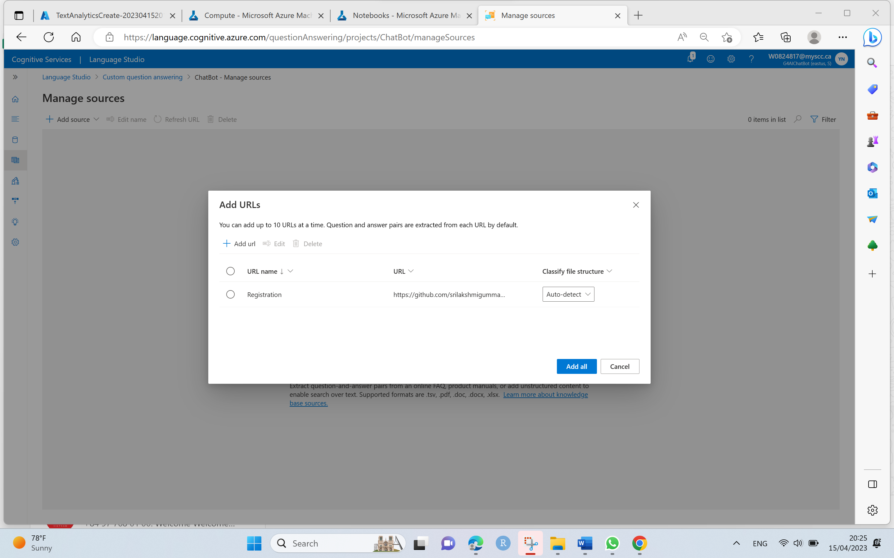

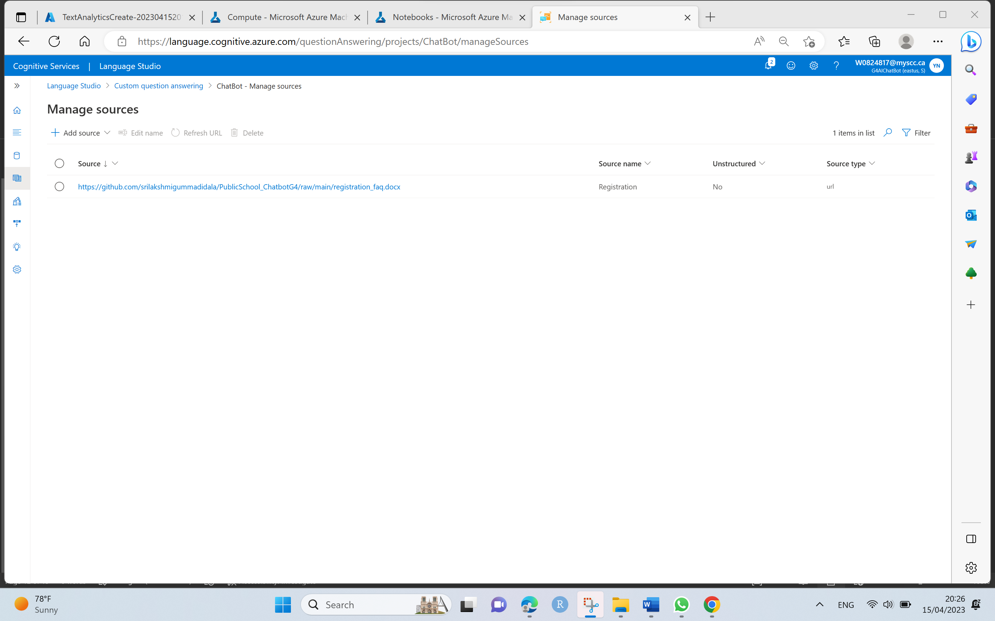

Step 8. Edit the knowledge base from the left-hand side panel and add question pair.

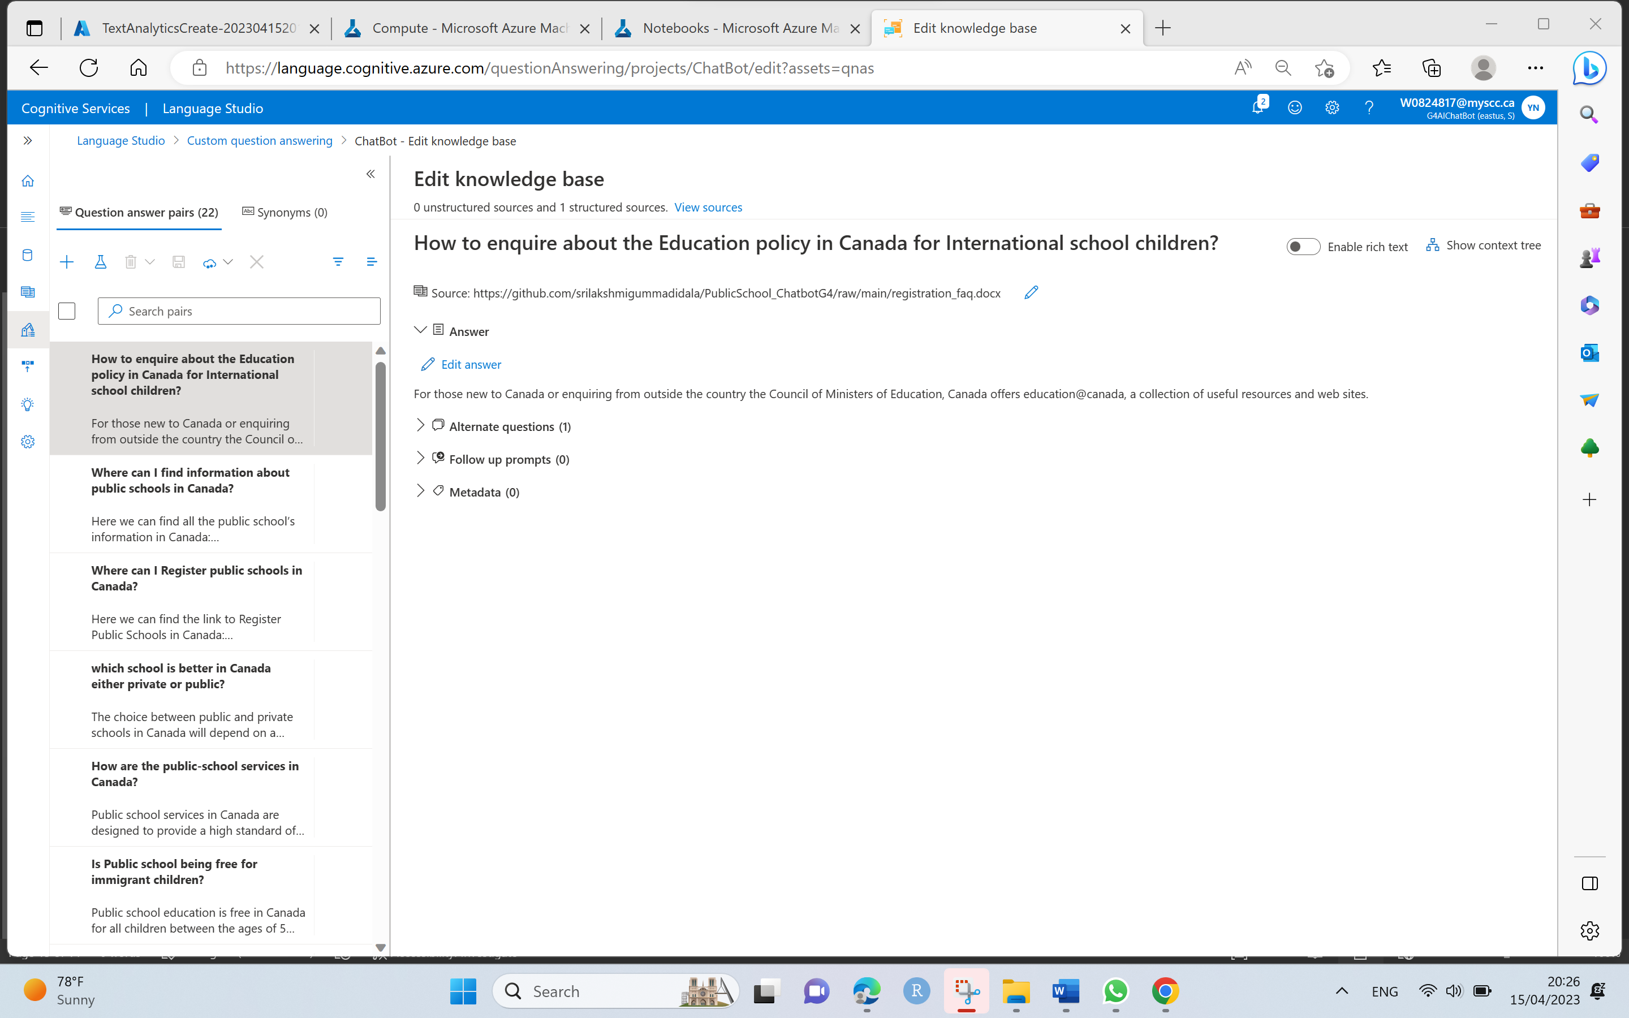

* Add Question **Hi** and Answer **Hello!** With the source of knowledge base url as given earlier and save the changes.

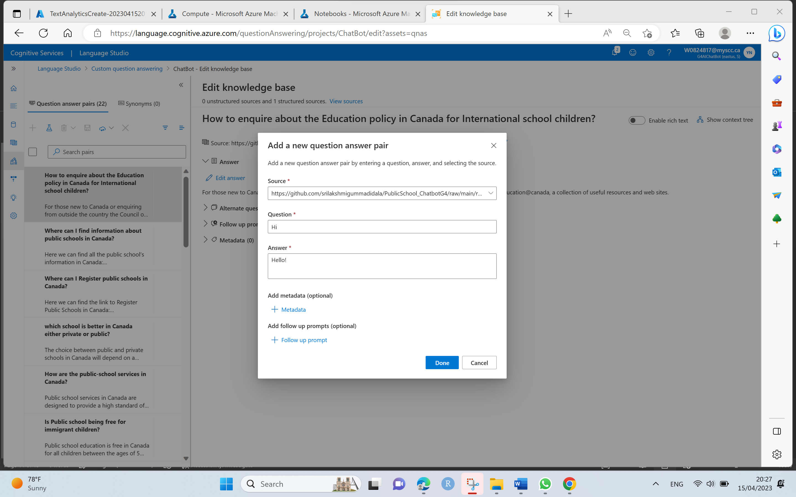

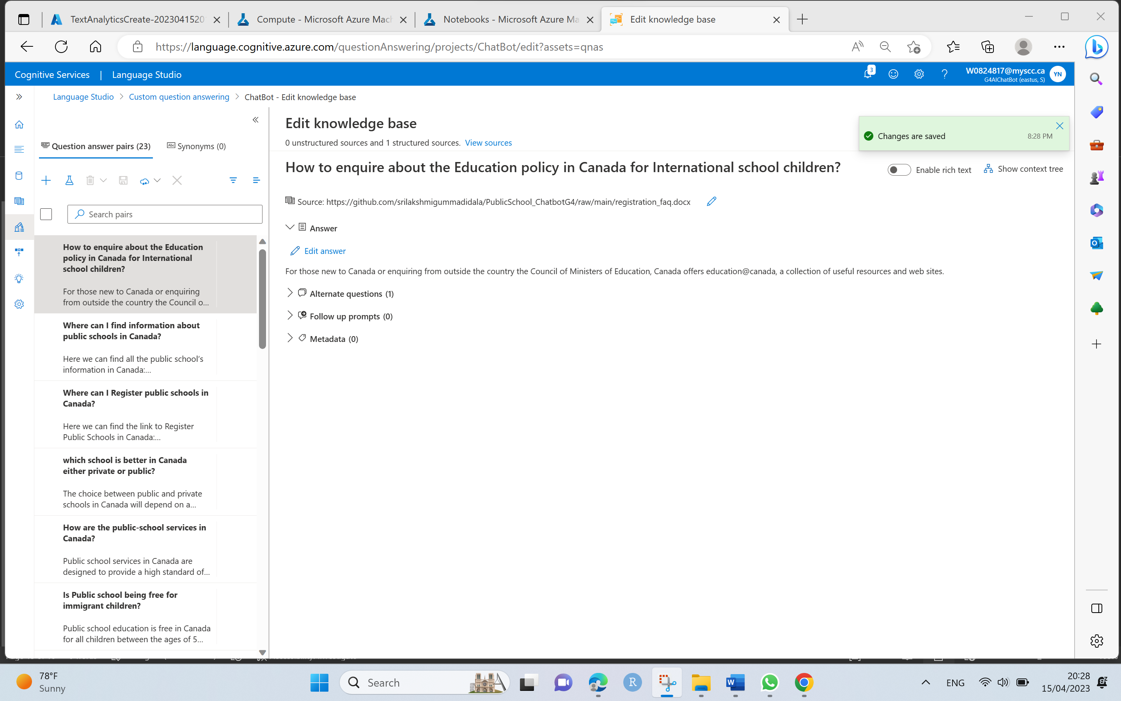

Step 9. Train and test the knowledge base once the sample question and answers are submitted and saved the changes as below.

* At the top of page, click on the Test to test our knowledge base.
* In the test panel, at the bottom enter the message **Hi**,the response from the bot **Hello!** should return as below.

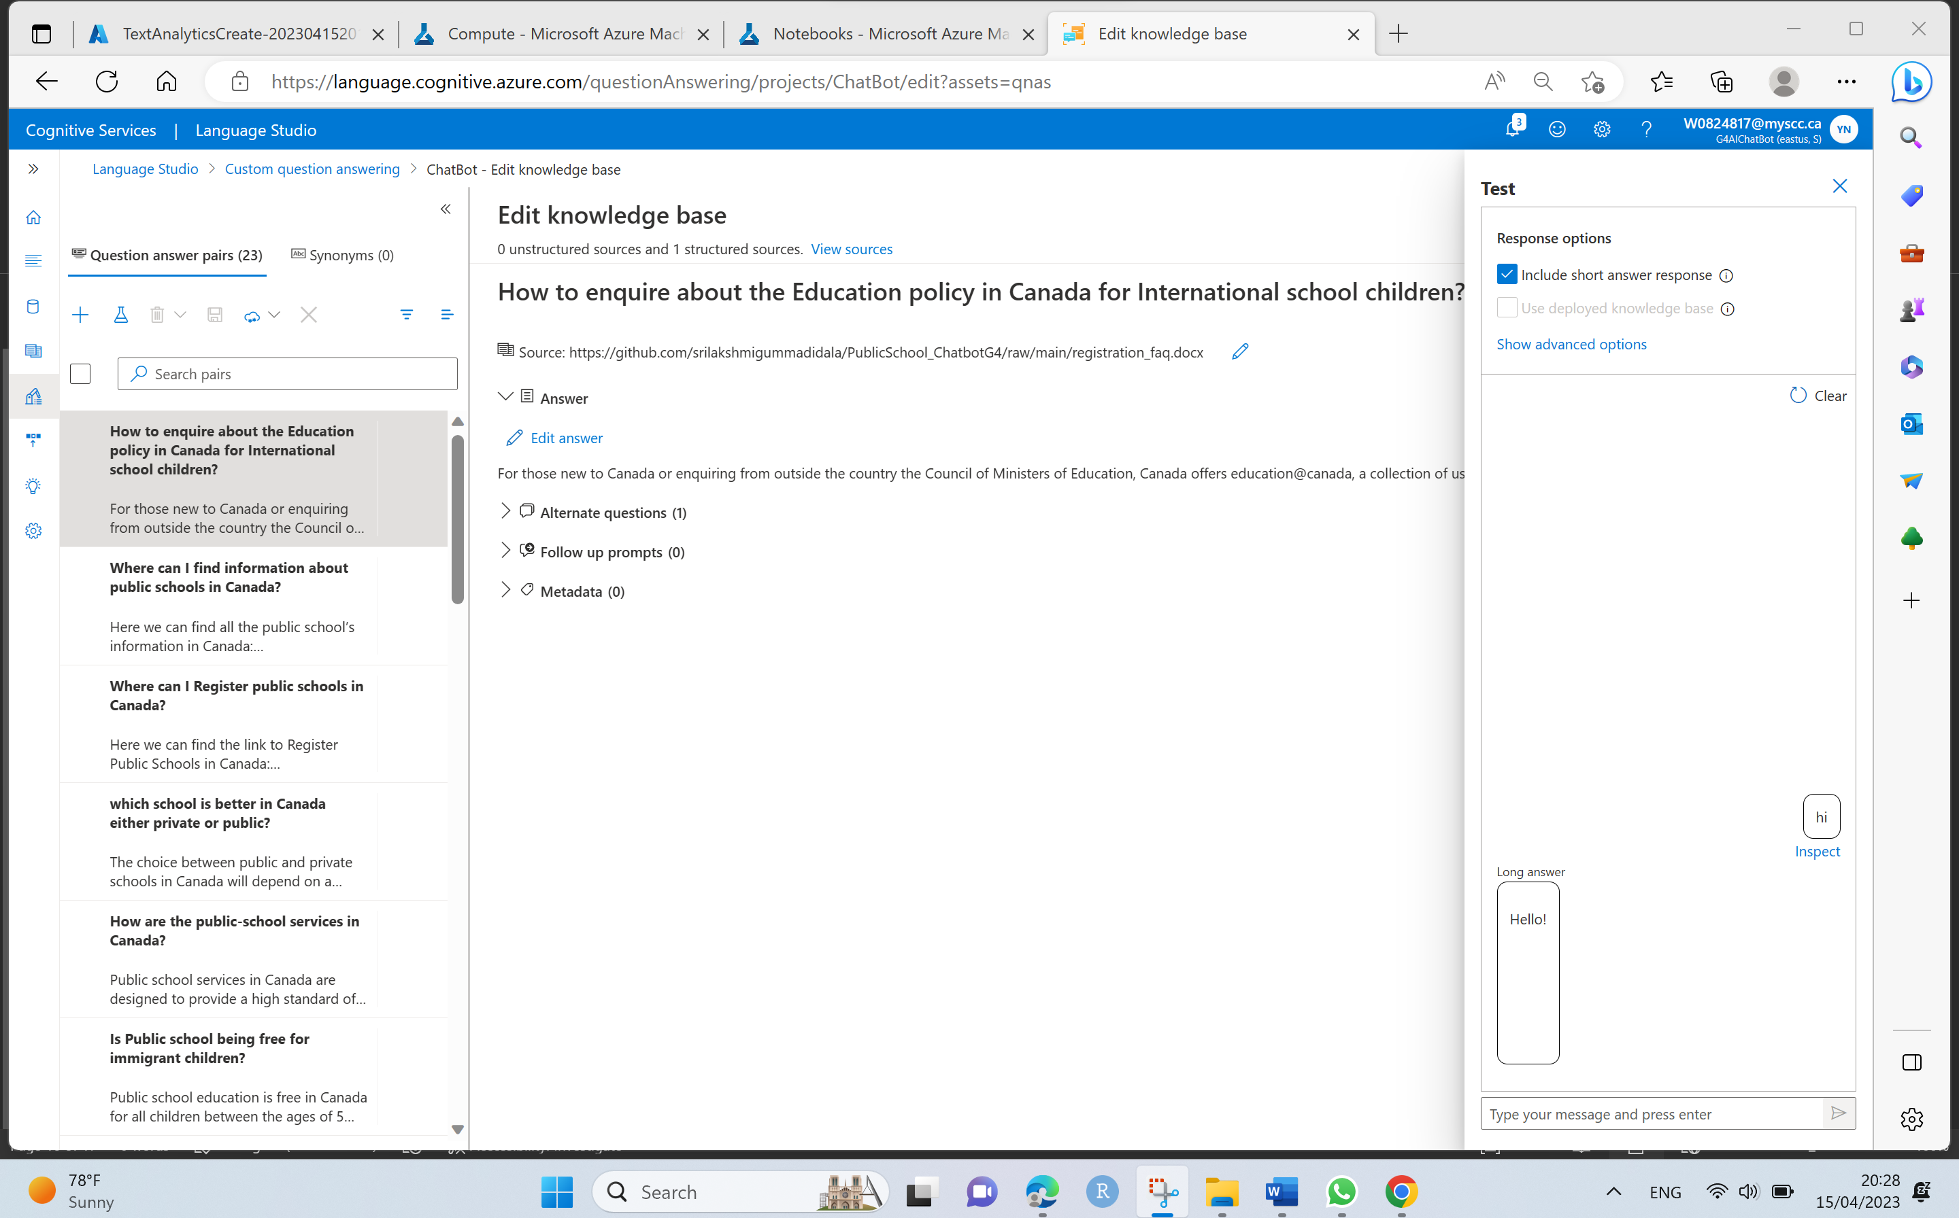

* Test with some other questions in the test pane, the appropriate response from knowledge base FAQ should be returned.

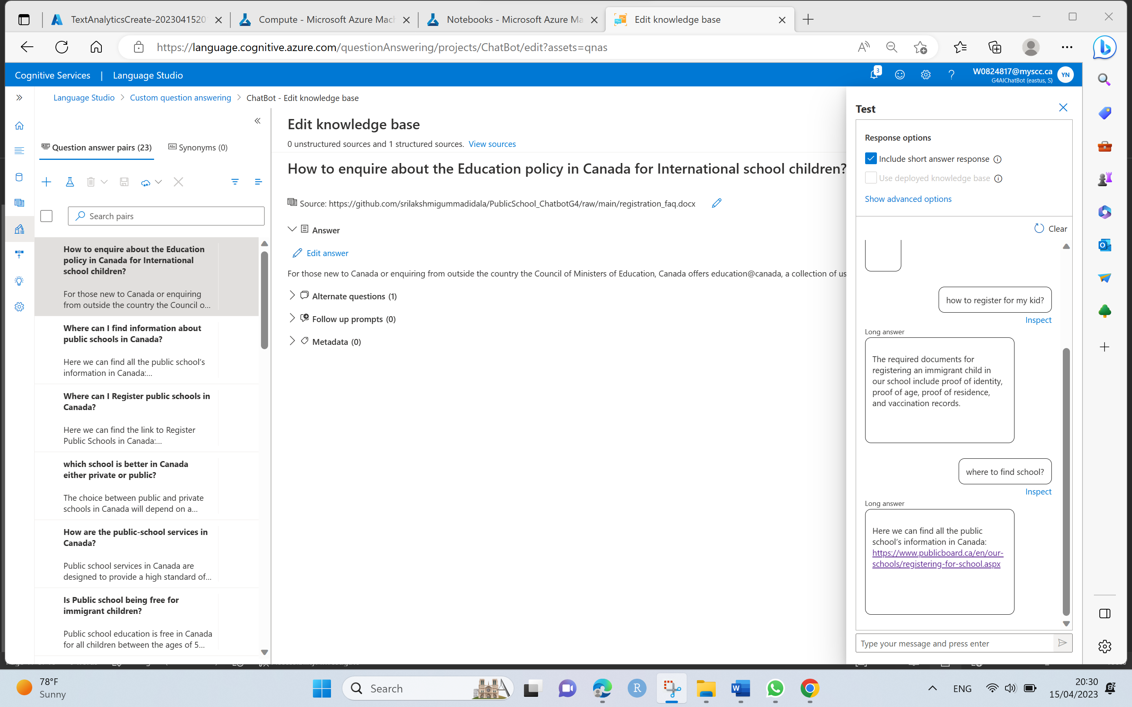

Step 10. Create a bot for the knowledge base.

* The knowledge base provides a back-end service that client applications can use to answer questions through some sort of user interface.
* To make the knowledge base available to a bot, we must publish it as a service that can be accessed over HTTP.
* At the top left of the language studio, click on Deploy Knowledge base which we created and tested in the previous steps.

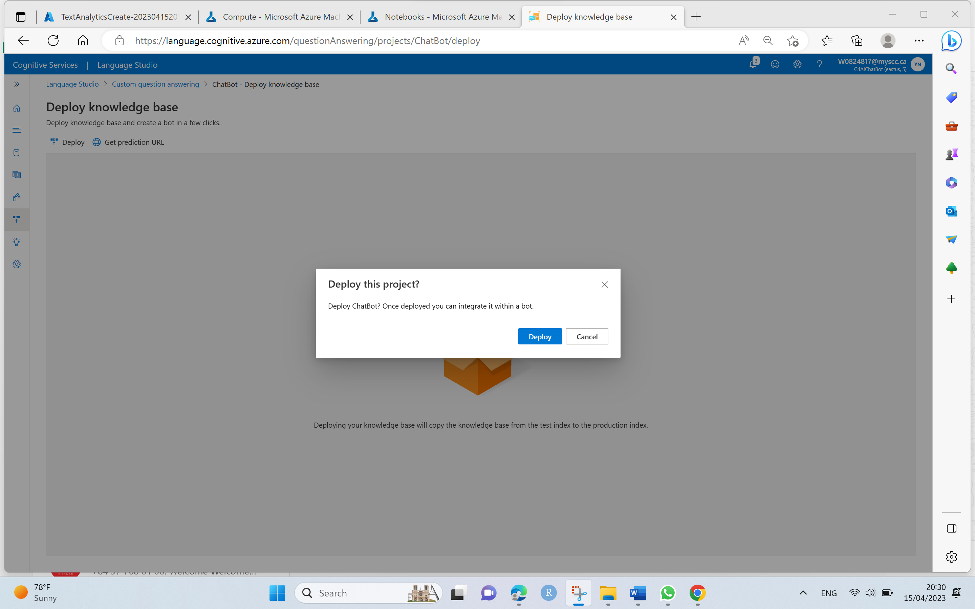

* Once the service is deployed, click on Create a bot as next steps which eventually opens a new Azure browser tab to create a Web app bot with our Azure subscription.

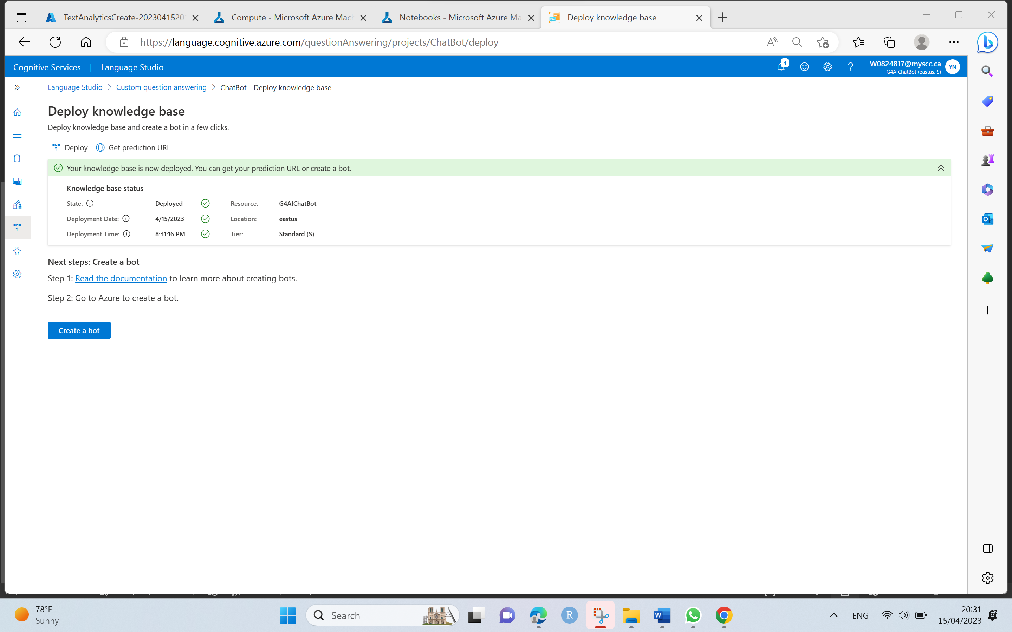

* Add the following settings with the project details such as Resource group, Region and Azure Bot which are pre-populated, Pricing which is standard tier and Microsoft App ID creation type, choose the Create new user – assigned managed identity.

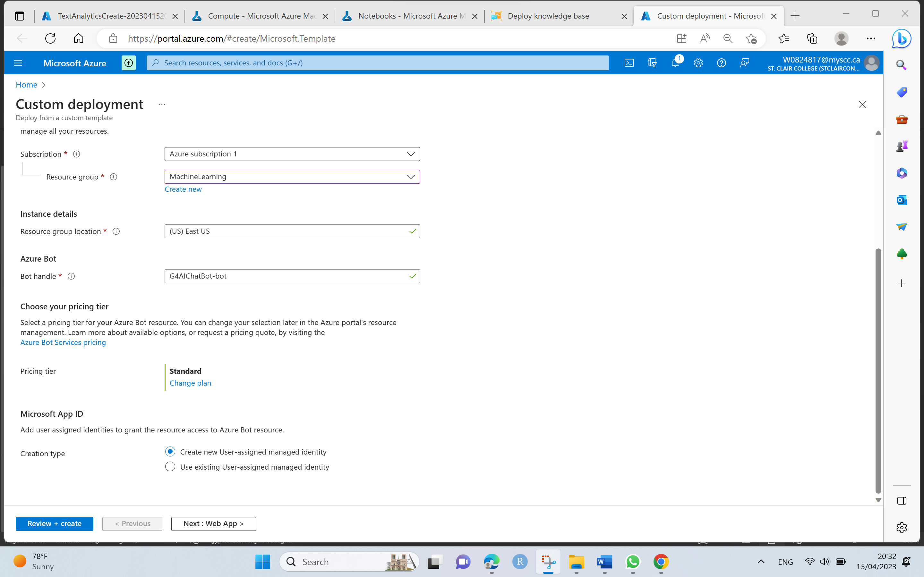

* To continue updating the settings, go to Azure portal, on the home page, click on Resource Groups and locate the resource group which we created for our language resource.
* Select language resource and navigate to its left-hand menu. Then select Keys and Endpoint under Resource Management. Copy the key1 and update the key for Language Resource Key.

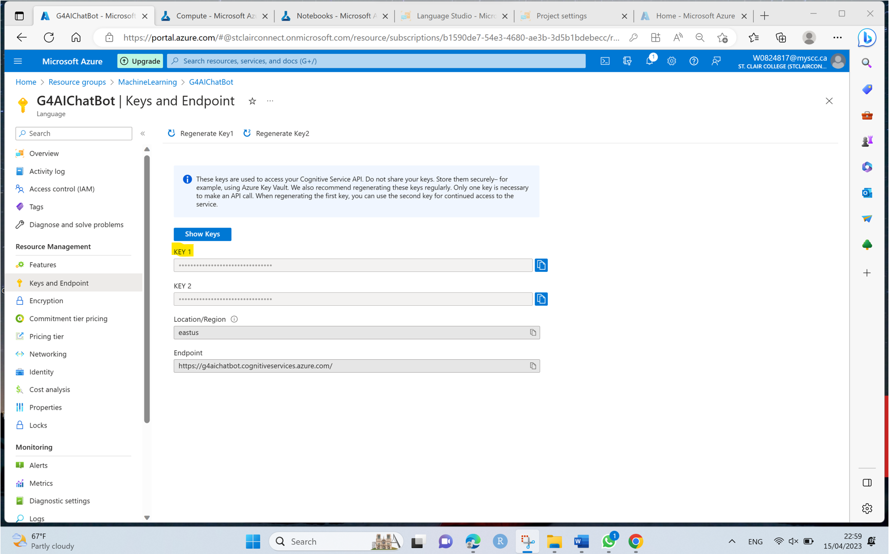

* Give the Language project name and check the other inputs which are pre-populated as per the previous steps.

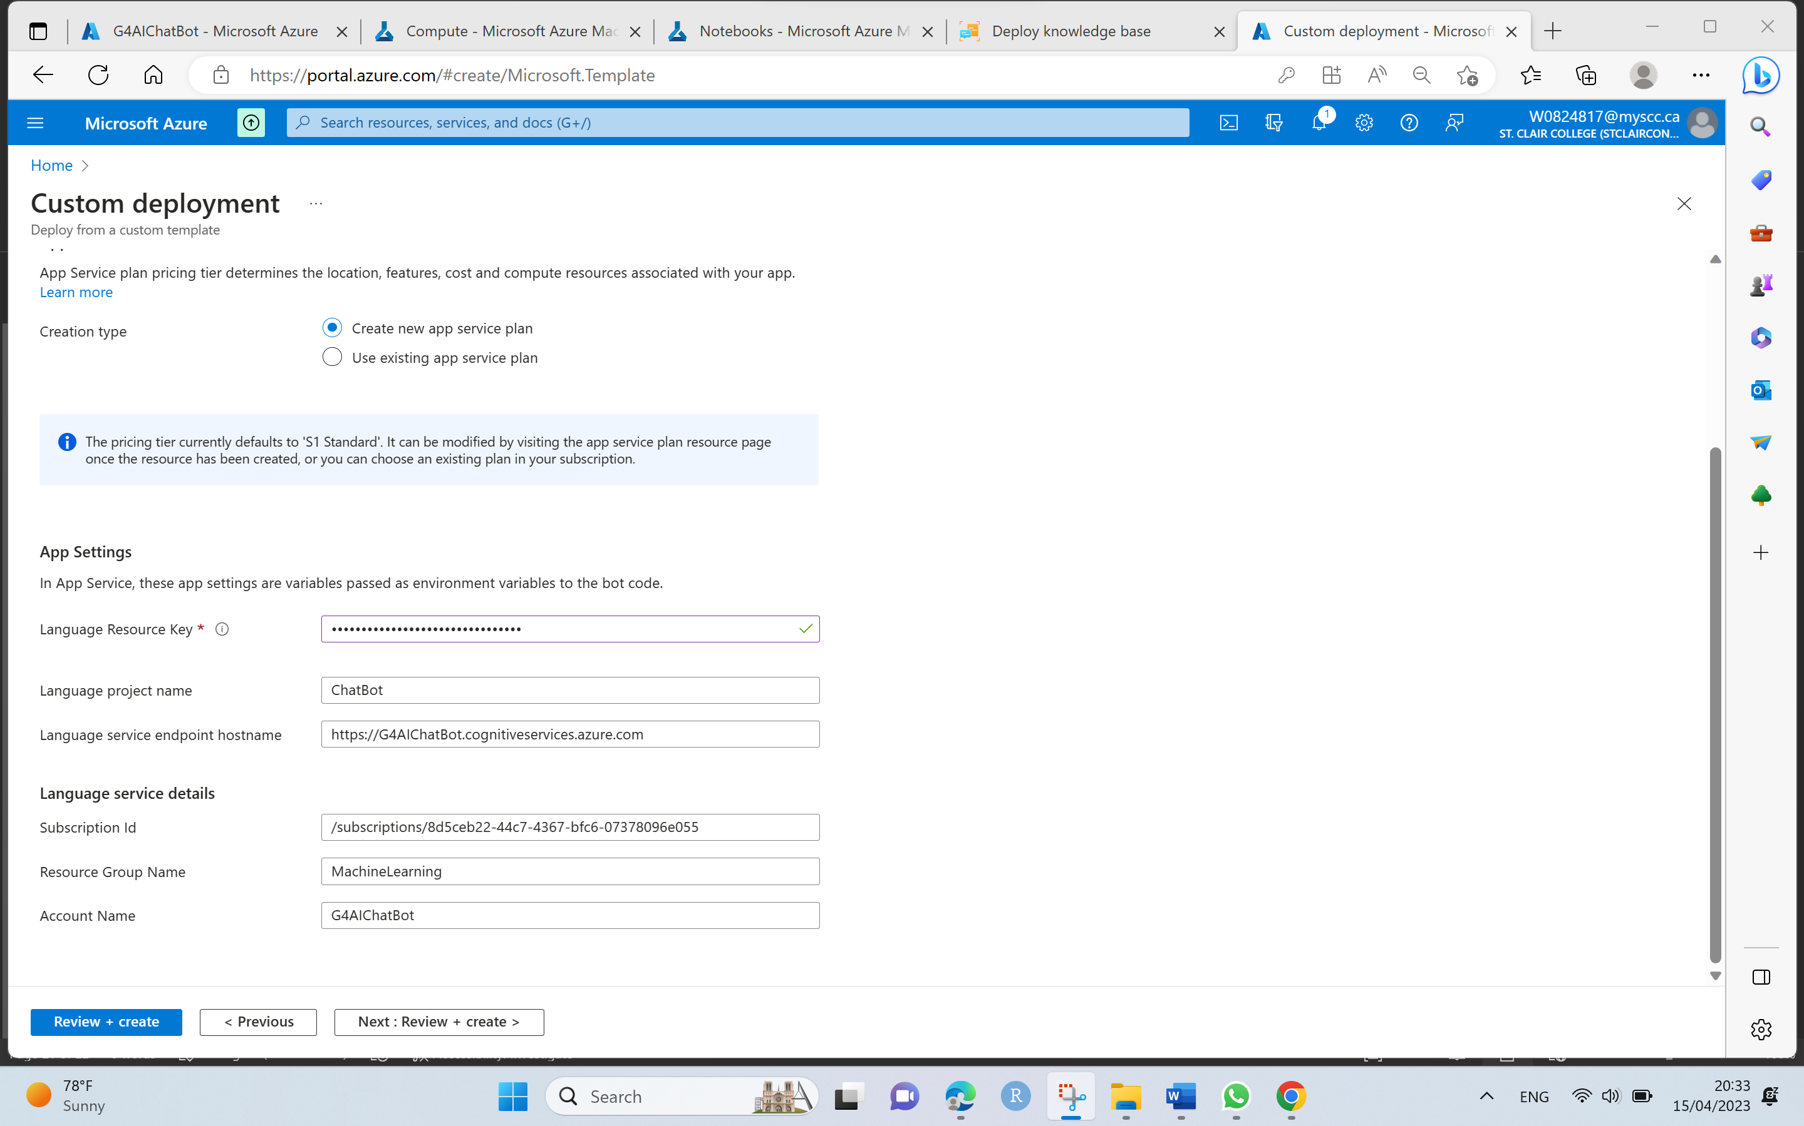

* Click on Review + Create, once Validation passed, click on Create a bot.

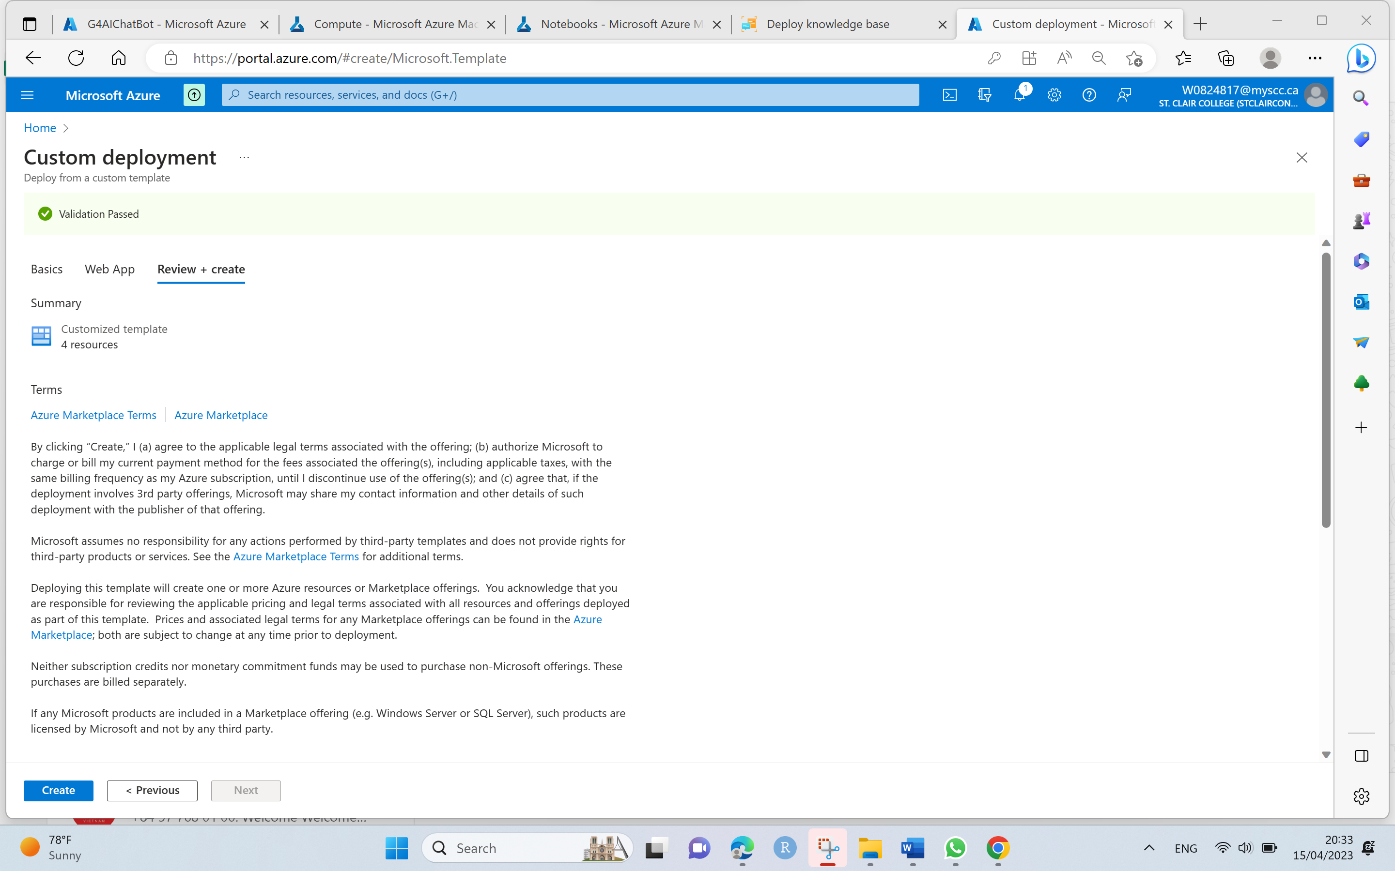

* Wait for bot creation and once the deployment is complete, go to Resource group.

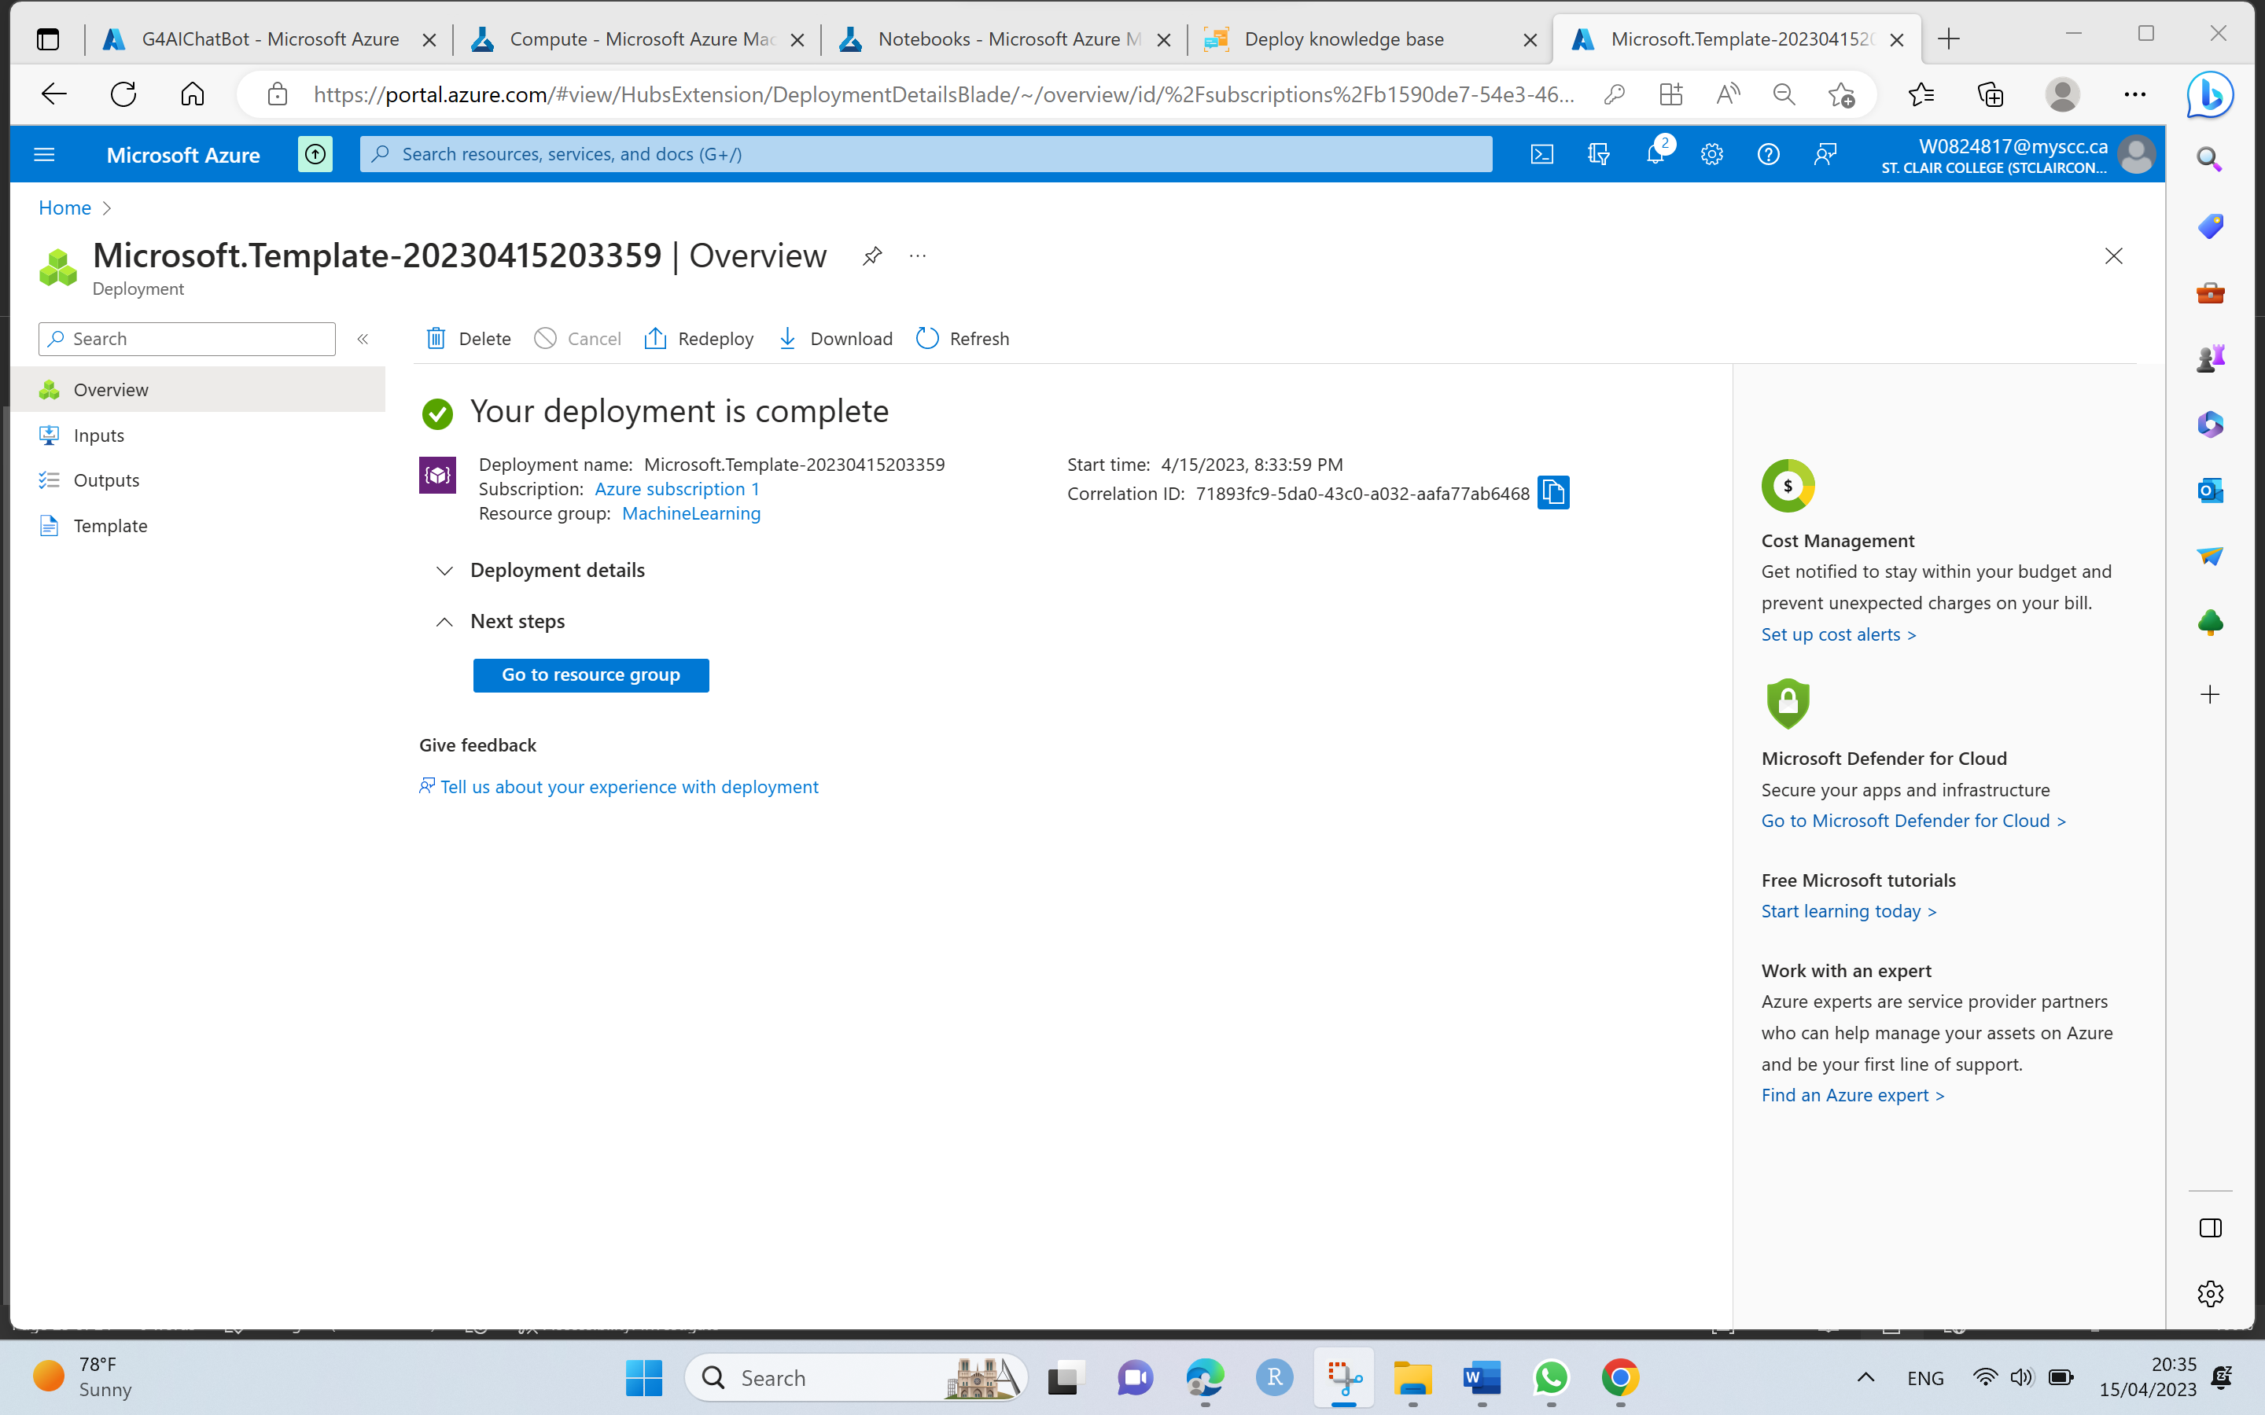

Step 11. Test in Web Chat

* After deployment, test a bot in Web chat by navigating to Azure machine resource group and select the Azure bot which is created previously and in the left side panel, under settings select Test in Web Chat option to test our above created bot.

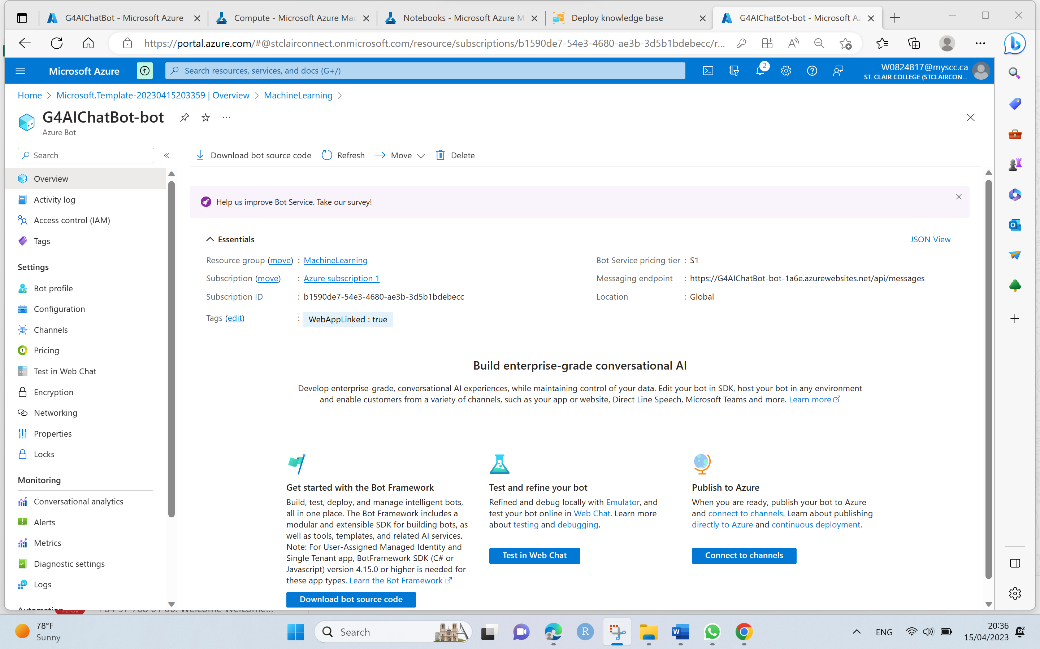

* Go to Channels and select the channel as Web Chat.

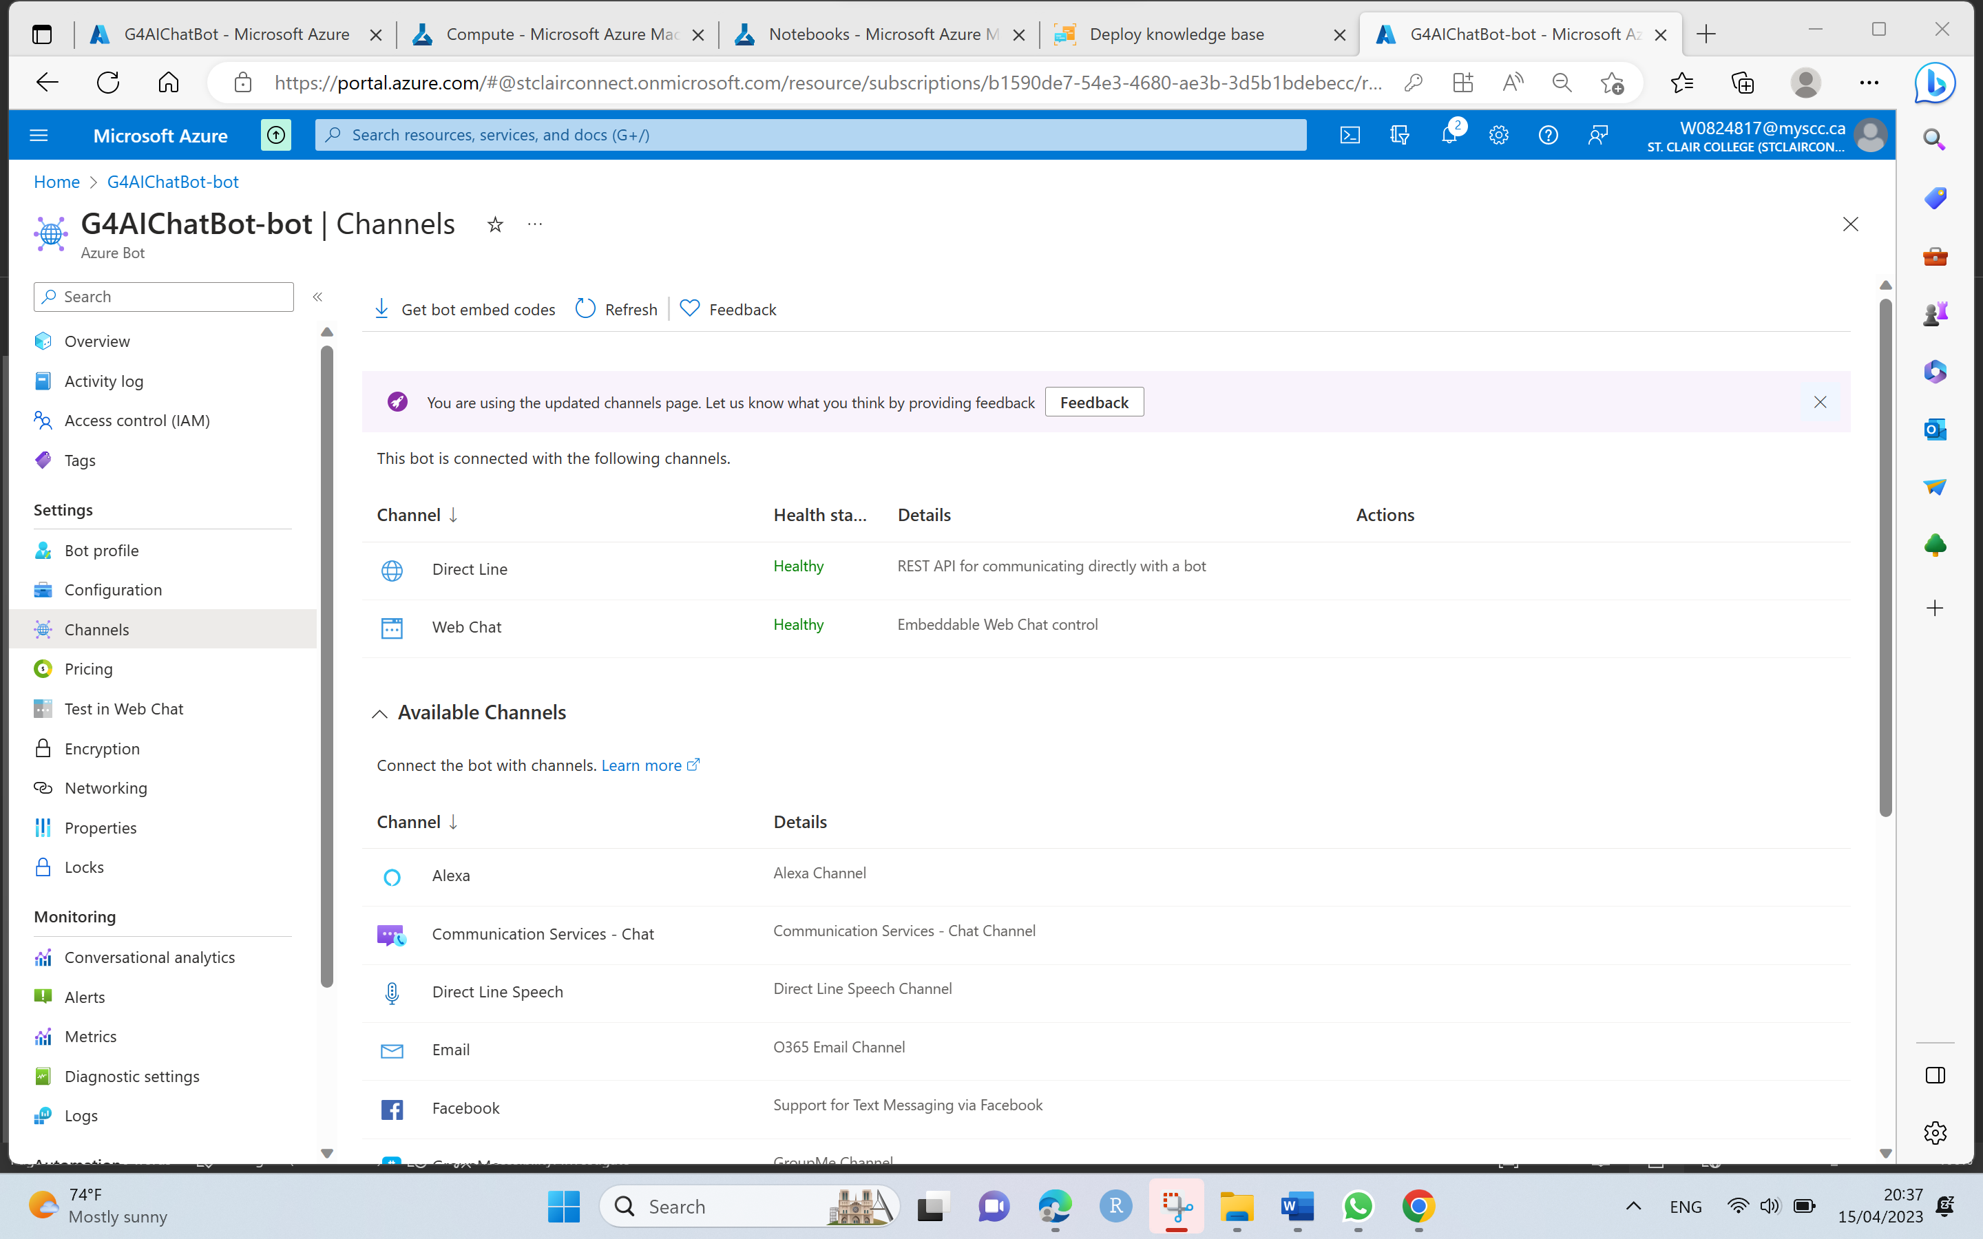

* Click on Edit, which opens settings page where we can get the embed code to embed our bot in a web page.
* To embed a bot, we need HTML embed code and secret key which is generated for our bot.
* Copy the embed code and paste it into QnA python notebook which is opened in Step 3 by replacing the default information YOUR_SECRET_HERE to secret key from below settings page.

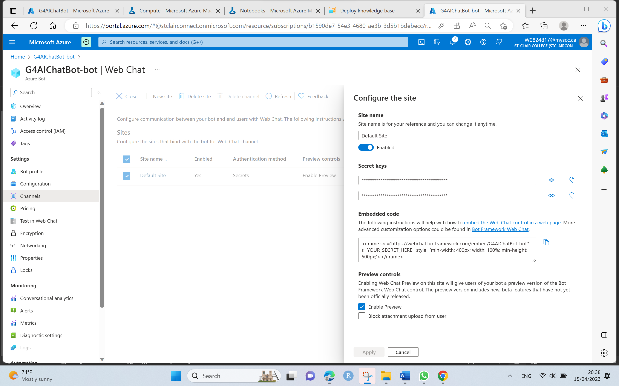

* After adding the embed code along with secret key, run the code in QnA python nodebook to render HTML chat interface.

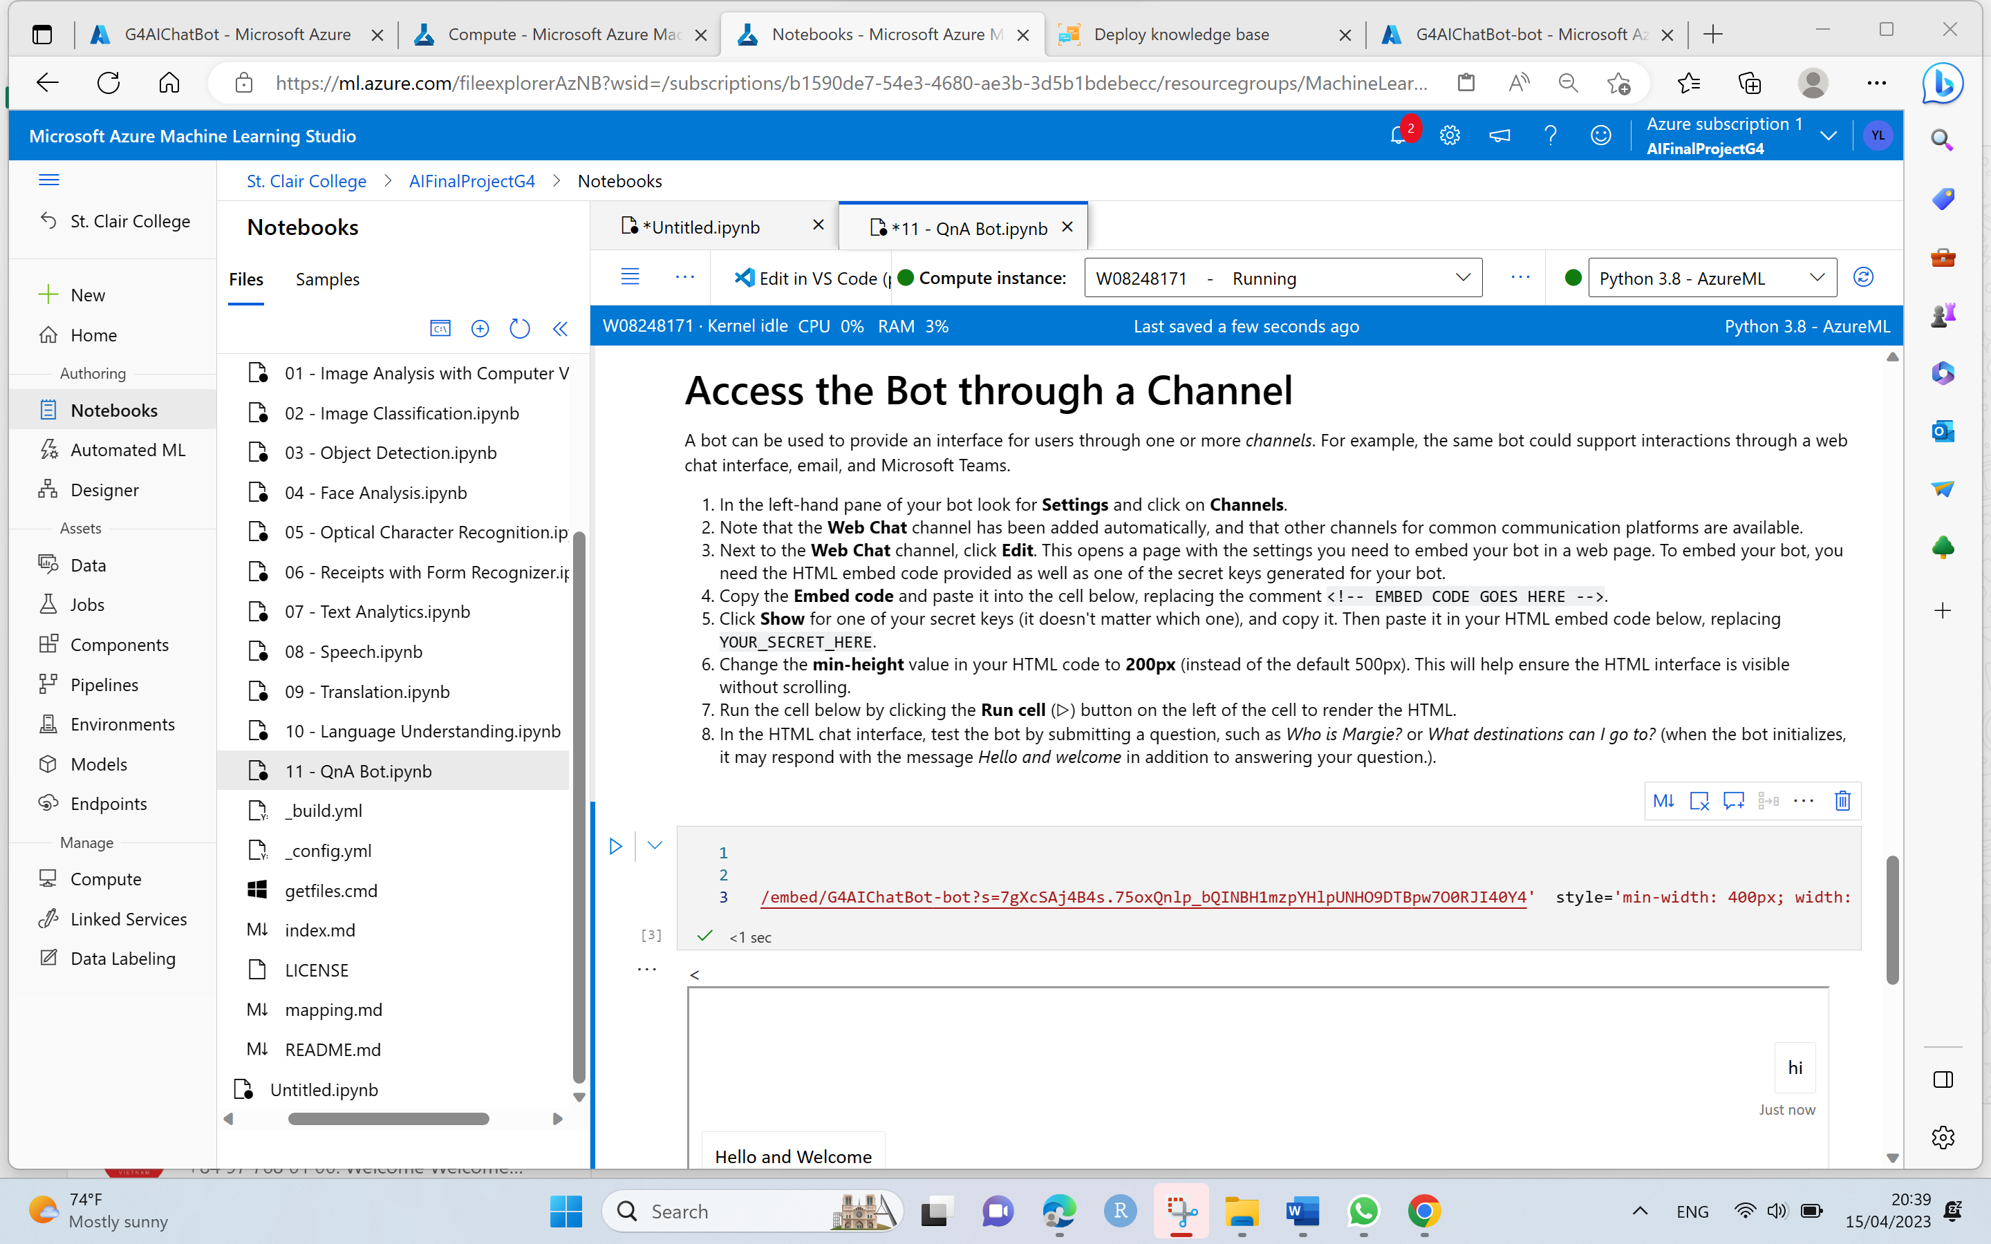

* From the HTML chat interface, test the bot by giving a Question, such as How to Register public school in Canada or how to check ranking of public schools in Canada or anything related to Public School Registration process for Immigrant children as per the knowledge base created.
* Experiment with the bot by giving related FAQs, Bot should respond with appropriate answers as trained by the knowledge base.

